Project Report

|  |  |
| --- | --- |
| Project Title | Design, Develop, Implement, Test & Document Used Car Sales Portal Website |
| Qualification Name (NICF) | Advanced Certificate in Software Applications (Development and Process) |
| Product Name | ABC Cars Pte Ltd Portal |
| Module Name (NICF) | Application Development & Process |

|  |  |  |  |
| --- | --- | --- | --- |
| Student name | | Assessor name | |
| I Kadek Adi Astawa | |  | |
| Date issued | Completion date | | Submitted on |
| January 30 2023 | February 17 2023 | | February 17 2023 |
|  | |  | |
| Project title | Design, Develop, Implement, Test & Document Used Car Sales Portal Website | | |

|  |
| --- |
| Learner declaration |
| I certify that the work submitted for this assignment is my own and research sources are fully acknowledged.  Student signature: Date: February 17 2023 |

Content

1. **Project Background**
2. **Project Objectives**
3. **Project Requirement Specifications**
4. **Task 1**
5. **Task 2**
6. **Task 3**
7. **Task 4**
8. **Task 5**
9. **Task 6**
10. **Task 7**
11. **Task 8**

Project Background

We were approached by 'ABC Cars Pte Ltd' as a website developer to develop a used car sales portal. Users will be able to register on the portal using the registration page. Portal users can search for cars by make, model, registration, and price range. Users will be able to see car information after searching it. The portal allows users to log in and post cars for sale.

There are two types of users that will use this website, namely administrators and regular users.  
Admin can manage user information and all vehicles in the website, and users can only manage cars they post.

Project Objective

The purpose of this project is to be used to assess the students' summaries in the module

'Application Development & Process' of the NICF course "Applied Degree in Software

Engineering"

This project looks at the skills needed to design, implement, test, and document a

website for a used car sales portal using Spring Framework, MySQL server and testing

system by applying risk-based testing (RBT).

Learners must complete all the tasks in the project task list and prepare the following

During the project:

• Project implementation on the project's technical environment

• Prepare project reports according to predefined templates

• Prepare project presentations according to predefined templates

• Prepare website documents

**Tools & platform used**

1. Service



1. MySQL Workbench

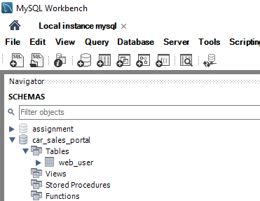

1. Google Chrome

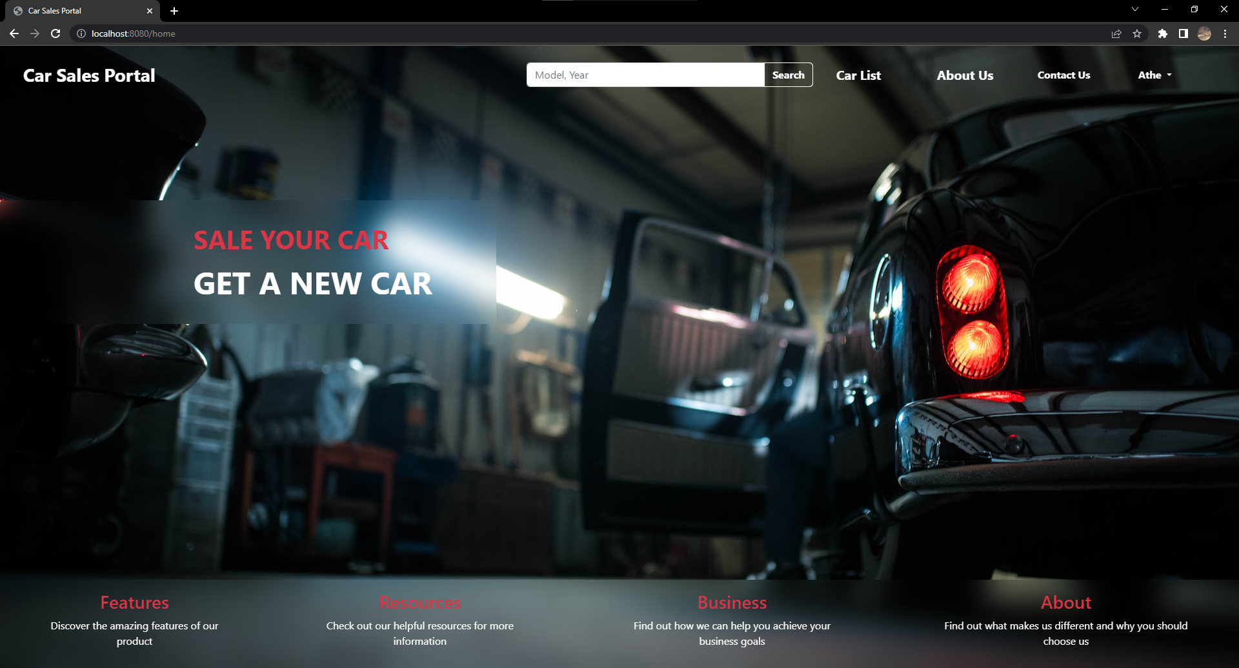

1. STS (Spring Tool Suite)

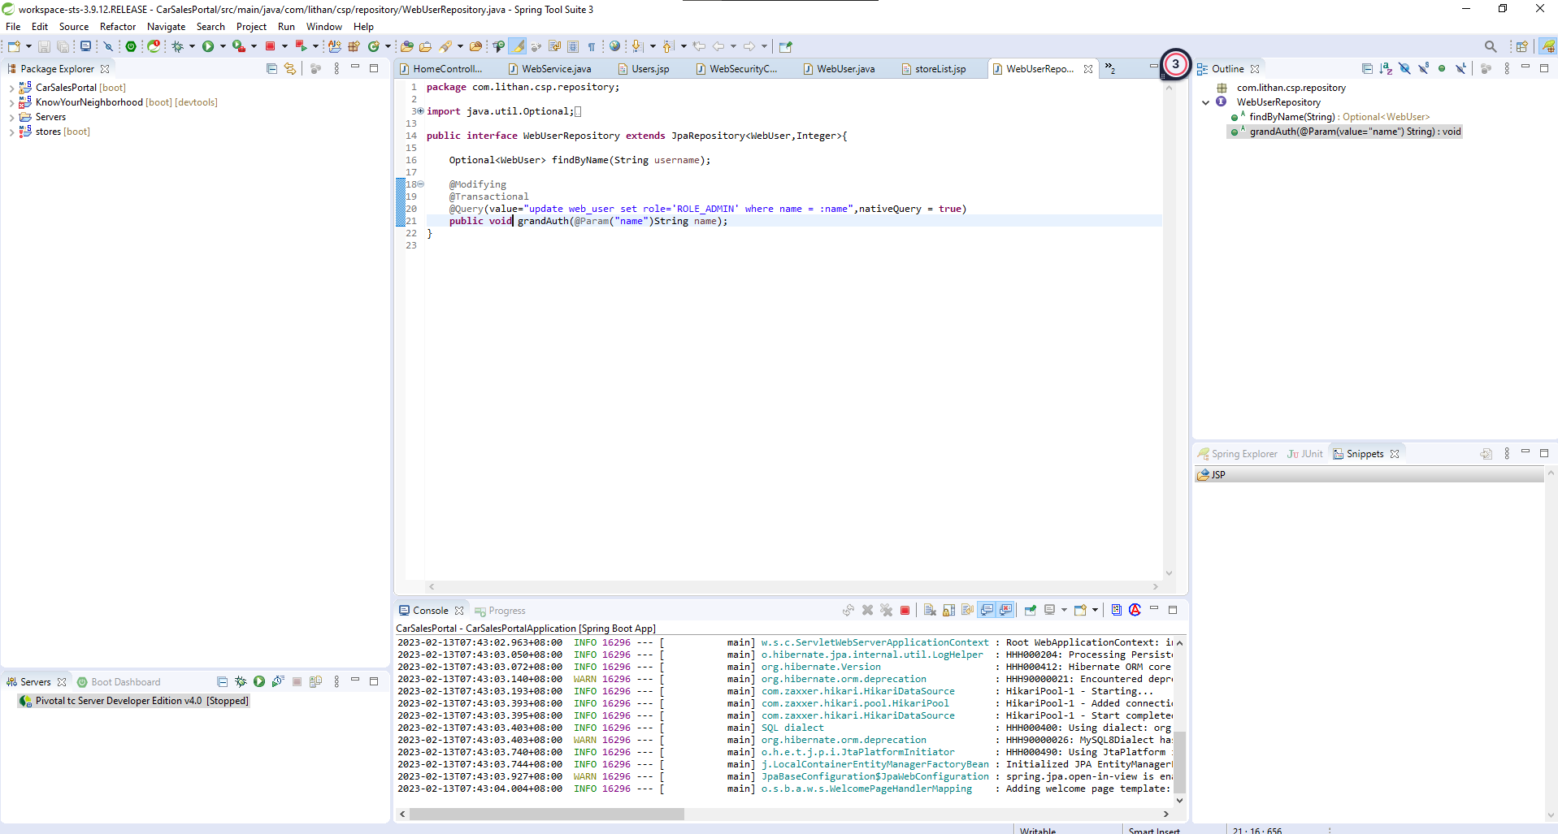

1. Microsoft Word

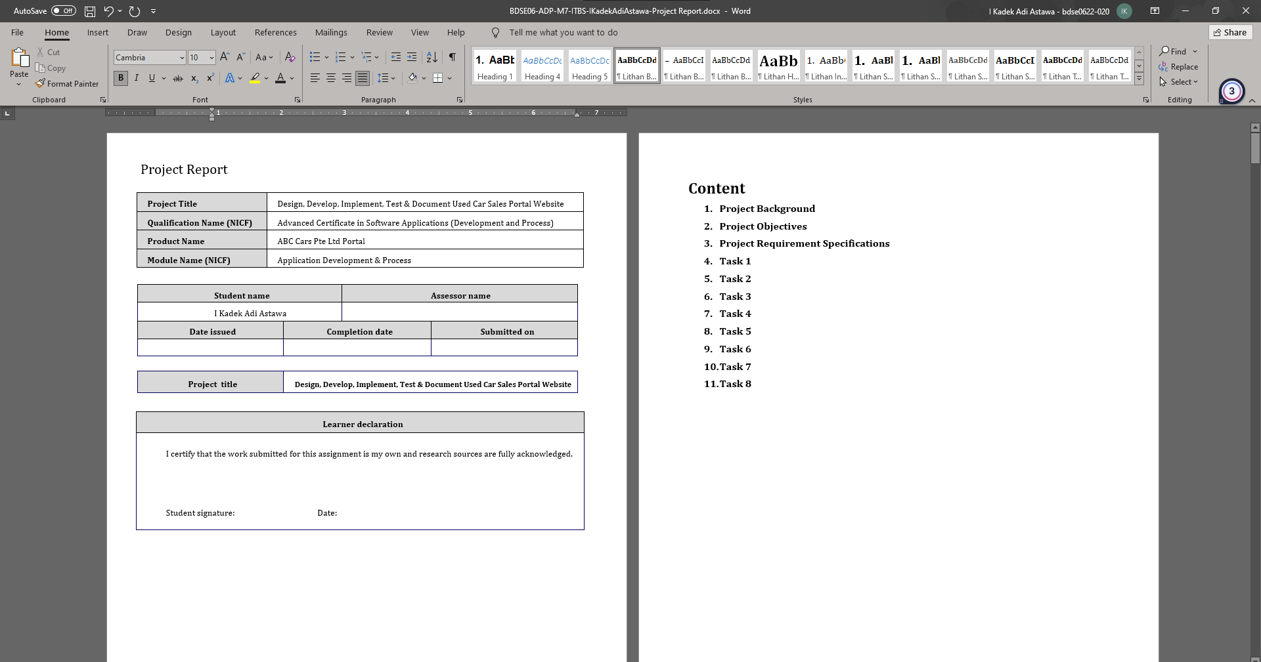

1. Microsoft Power Point

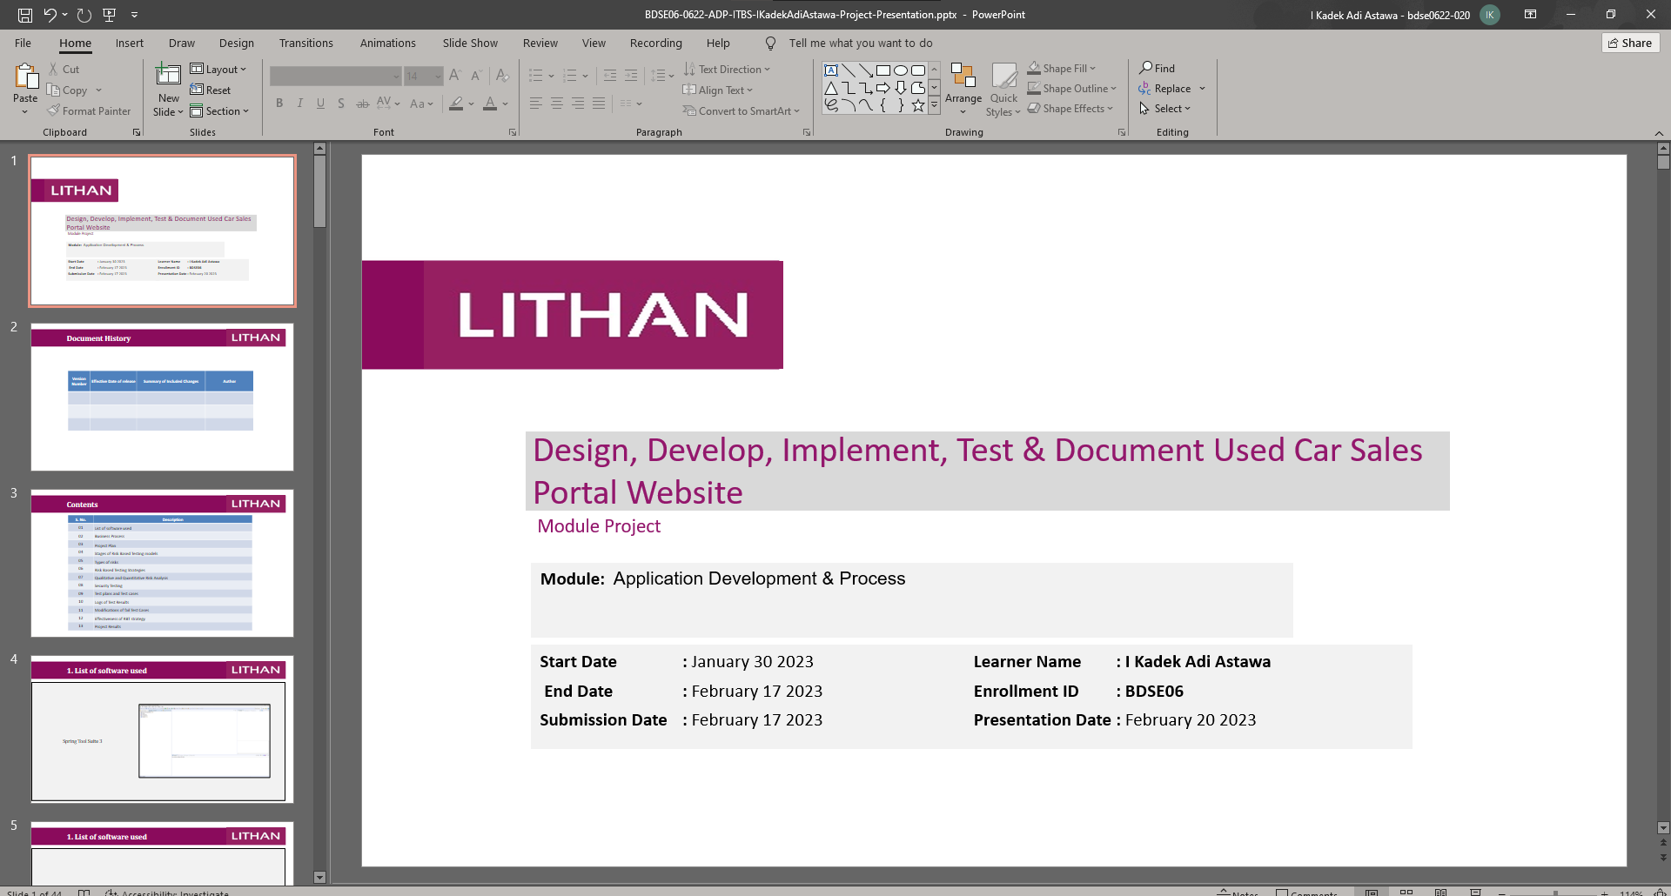

Project Requirements Specifications

* 1. Project Scope

There are 2 types of users in this Used Cars Sales portal. They are

* Users
* Administrator

User

1. Register Page
2. Login Page
3. Post the Car for sale
4. View Car Details
5. Visit Home Page
6. View Car Listing
7. Search Car by make, model, registration
8. Bid for the car
9. View About Us Page
10. View Contact Us Page
11. Logout

Admin

1. Login into administrator panel
2. Turn user to admin
3. Manage Car
4. Logout
5. Visit Home Page
6. View Car Listing
7. View About Us Page
8. View Contact Us Page
9. Search Car by make, model, registration

3.2 Functional Requirement

The following pages will be developed and displayed in the project:

1. Registration Page
2. Login Page
3. About Us Page
4. Home Page
5. Post Car Page
6. Car List Page
7. Biding Page

Task 1

Task Statement:

Create the following items Under “Business Process Section” in Project Presentation

1. Explain the Business Processes the Software is supporting
   1. Document 2 Business Process
2. Document 2 Module functionality
   1. UI Screenshots
   2. Functionality of each of the Screen

Solution:

* 1. Explain the Business Processes the Software is supporting
  2. Document 2 Business Process
     1. Scenario 1 Post a Car

First user needs to log in to access the post car page, post car page is located on “ My Store Page ” and select if the car will be a bidding car or just a regular car. In the post car form, the user needs to fill in the form fit for the car criteria and click the post button.

* + 1. Scenario 2 Biding a Car

To bid on a car, the user must go to the auction page, and next to the "View Details" button is the "Bid This Car" button. Clicking this button will open a form for you to enter the amount you wish to bid on. To see a list of bidders for the same car, click the "View Details" button on the car map on the site and a list of bidders for that car will be displayed.

* 1. Document 2 Module functionality
  2. UI Screenshots

My store page

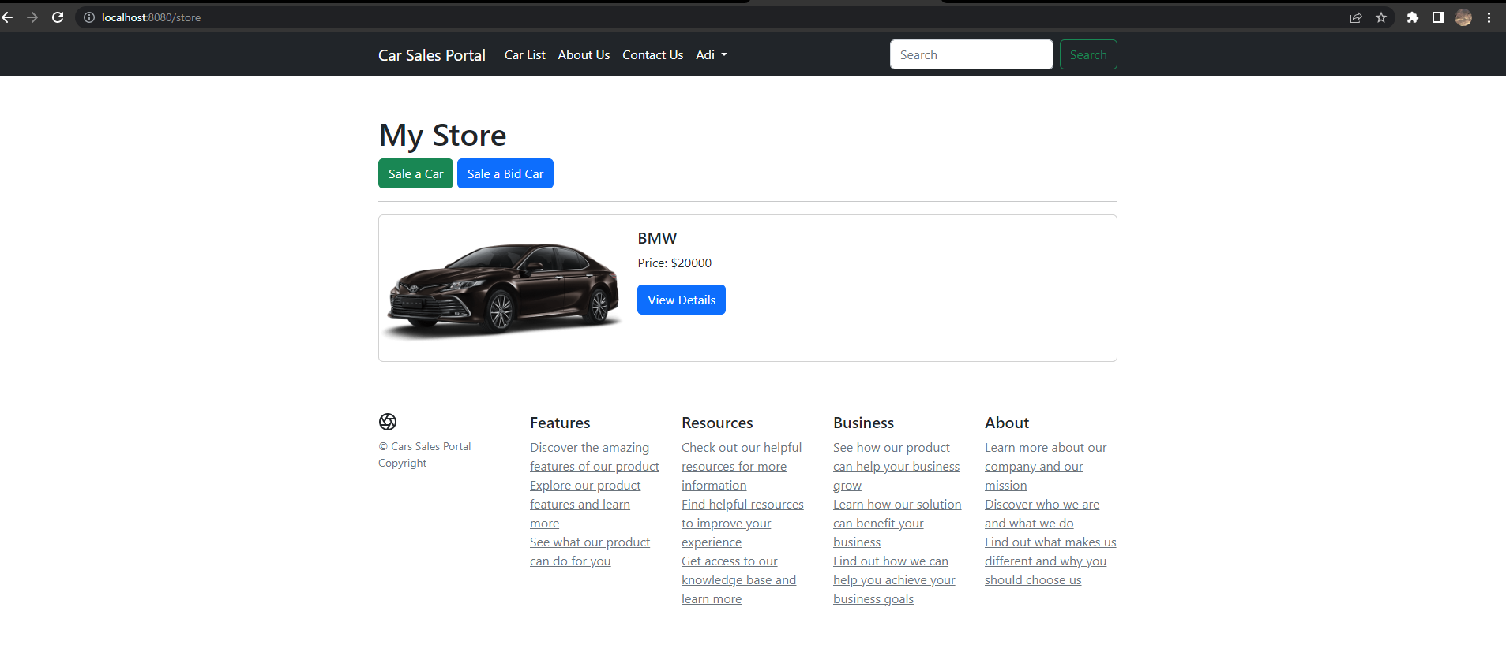

Post car page

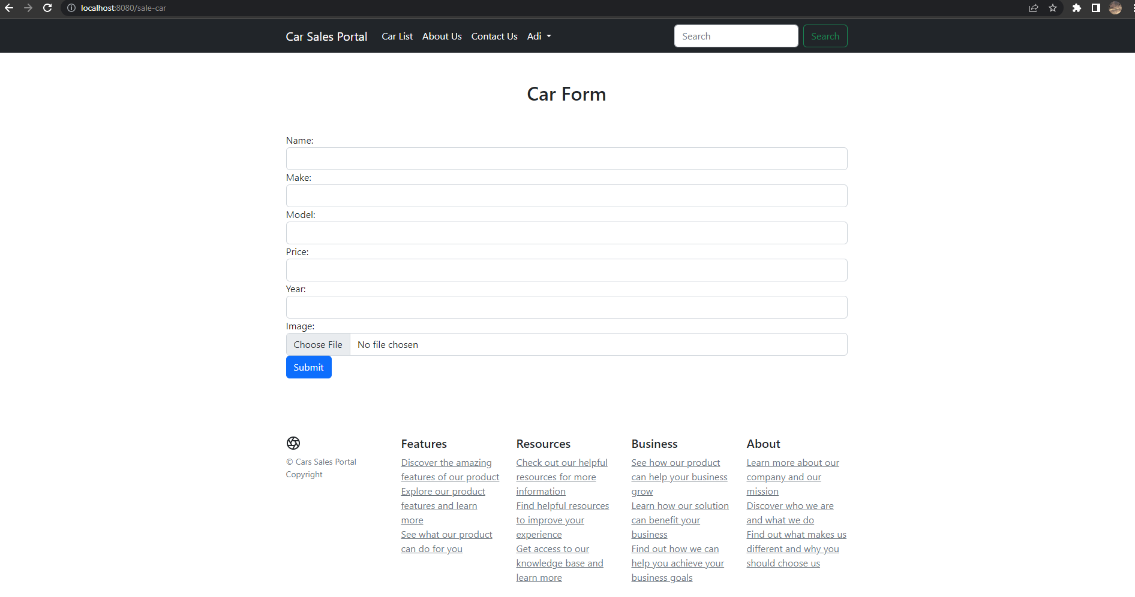

Bid Car detail page

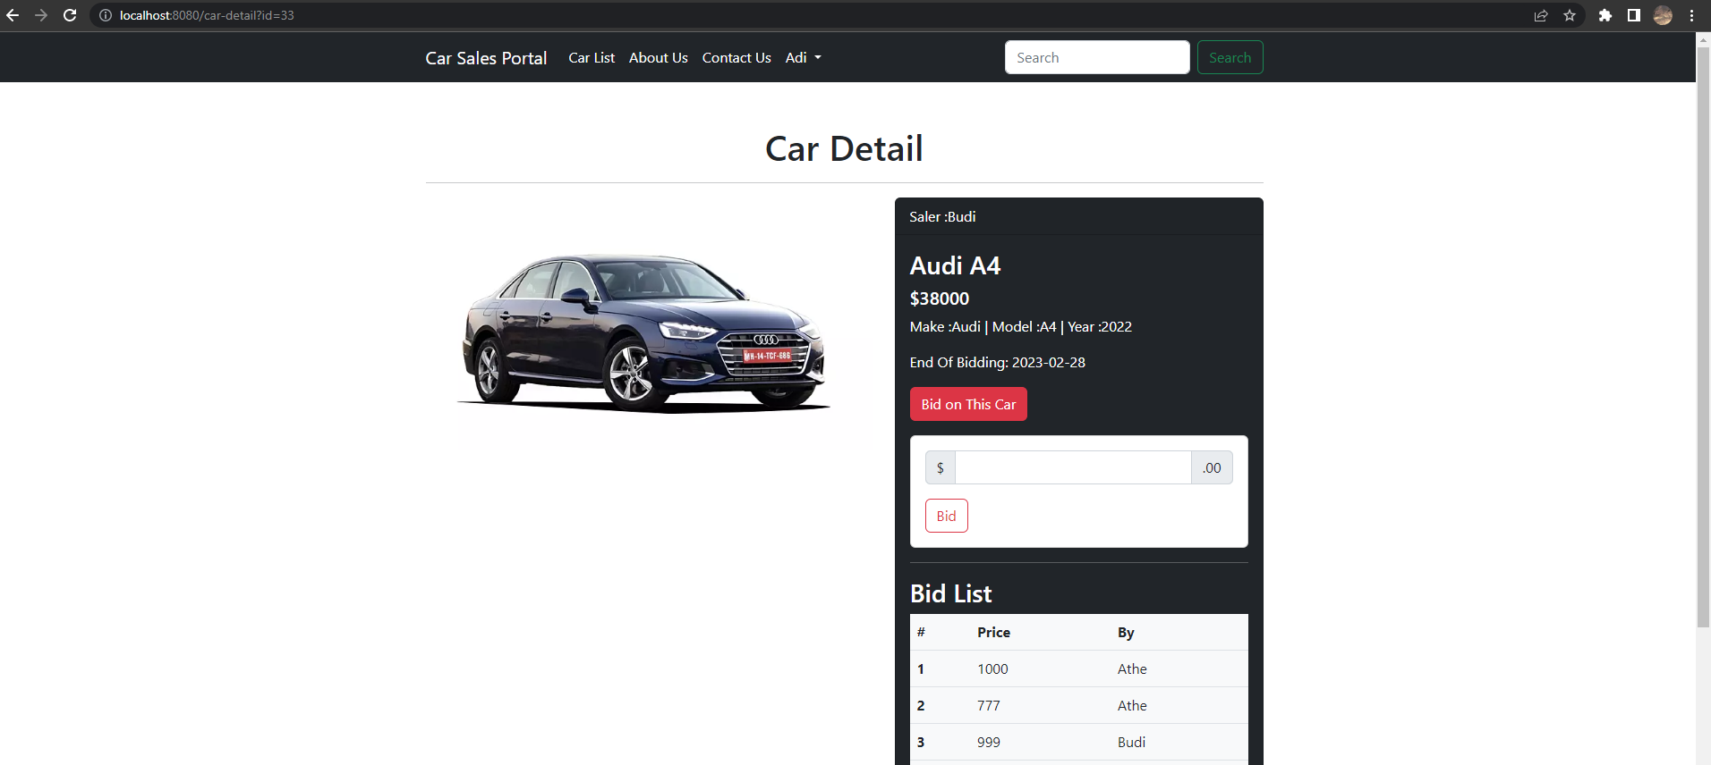

* 1. Functionality of each of the Screen

|  |  |
| --- | --- |
| Pages | Functionality |
| My Store Page | To view all car you sell, and add new car |
| Post Car Page | To post a car |
| Bid Car Detail pape | To get car detail information and bid for a car |

Task 2

Task Statement:

Create the following items in “Project Plan in Project Presentation

1. Detail the Software Development Methodology to be used for developing system
2. List the various tasks to be done during various phases
3. Create the Project Plan detailing the various steps to be carried out along with dates and Timelines

Solution:

* 1. Detail the Software Development Methodology to be used for developing system

Spiral model.

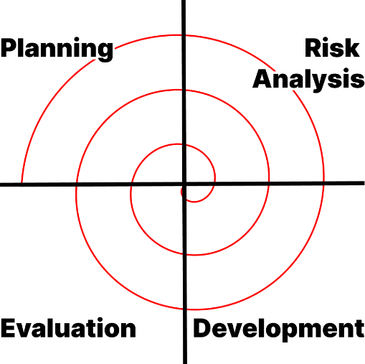

The reason for using the spiral model in this project is that it offers great flexibility. A spiral model allows the project to be modified during development based on the customer's requirements. Additionally, the spiral model facilitates risk management by identifying and assessing risks at every stage of software development.

* 1. List the various tasks to be done during various phases

1. Planning
2. Deciding the purpose and scope of this project.
3. Define the project schedule.
4. Analyze risks that may arise during the project.
5. Identify project requirements.
6. Decide the tool that will be used.
7. Risk planning
8. Analyze every risk that might happen in this project, and prioritize them based on their severity.
9. Create a response plan for each risk, this plan should include how to handle the risk.
10. Monitoring the risk throughout the project.
11. Design, development and testing
12. Create a Prototype of Cars Sales Portal.
13. Create all the view and map them.
14. Add spring security.
15. Do testing to the application.
16. Customer evaluation
17. Assess suitability of the website.
18. Performance evaluation
19. Safety checking if the role system work not.
    1. Create the Project Plan detailing the various steps to be carried out along with dates and Timelines

|  |  |  |  |
| --- | --- | --- | --- |
| **Phases** | **Activity** | **Start Date** | **End Date** |
| Planning | Deciding the purpose and scope of this project. | 11 February 2023 | 11 February 2023 |
| Analyze risks that may arise during the project. |
| Identify project requirements. |
| Decide the tool that will be used. |
| Risk Analysis | Analyze every risk that might happen in this project, and prioritize them based on their severity. | 11 February 2023 | 11 February 2023 |
| Create a response plan for each risk, this plan should include how to handle the risk. |
| Monitoring the risk throughout the project. | 11 February 2023 | 17 February 2023 |
| Development & Testing | Create a Prototype of a Cars Sales Portal. | 12 February 2023 | 12 February 2023 |
| Create all the views and map them. | 13 February 2023 | 16 February 2023 |
| Add spring security. |
| Do testing on the application. | 16 February 2023 | 16 February 2023 |
| Evaluation | Assess the suitability of the website. | 17 February 2023 | 17 February 2023 |
| Performance evaluation |
| Safety checking if the role system works or not. |

Task 3

Task Statement:

Explain risk-based testing concepts and requirements with the following details

Solution:

* 1. Stages involved in RBT model
* Definition of Risk

Risk is a likely condition with a dangerous element, it refers to the possibility of an undesirable outcome or possible negative consequence in the future.

* RBT Stages

1. Risk identification

In this stage, the project team needs to documenting potential risks that might impact the website.

1. Risk analysis

After the risk is identified, the project team needs to analyze the risk, by doing this the risk will be sorted based on its impact to the website, and it will be easy to prioritize the risk.

1. Test planning

In this stage, the project team needs to create a test plan that focus on the higher risk based on the risk that have been analyzed.

1. Test executing

During this stage project team will executing the test plan based on the highest failure risk.

1. Test reporting

After executing the test, team project need to create a report about the result of the test.

* Eight Characteristics of Software Product Quality

**

* 1. Types of Risk

|  |  |  |  |
| --- | --- | --- | --- |
| Type of risk | Risk identification | Risk description | Impact |
| Functional | Login risk | User cannot Login | If the user cannot login to the website, user cannot use many functionalities of the website like buying or selling their car, and the user might go to other website. |
|  | Register Risk | User cannot Register | The user wouldn’t have the account to login to the website. |
|  | Bidding Car Risk | User cannot bid on car | The user cannot join to bid on the car which mean they have no chance to get the car |
|  | Post Car Risk | User cannot post a car | The user’s car cannot be seen by another user that might want to buy the car. |
|  | Search Risk | User cannot search a car | Any specific car will get hard to find because the search bar is not working. |
| Non-Functional Risk | Performance | Car listing page is not load in expected time | The user go to other website because tired the loading take more time. |
|  | Compatibility | Css doesn’t loaded in several browsers | The user finds it strange and the website might become very different from what it expected. |
|  | Maintainability | The code is hard to read | Other developer want to add some feature but confuse where to put the code. |
|  | Usability | Hard to search for car be cause the position of the search form | User want to search a car but cannot find the search form, it took a while to find the search form. |
| Technical Risk | Security | Other than admin role can access administrator panel | All data on database might get deleted by random user. |
|  | Portability | The website isn’t responsive | Mobile user want to access the web but the web view become untidy. |

1. Task 4

Task Statement

Create the following items under “Test Planning” in Project Report

1. Establish the test phases of security testing with its prioritization
2. Develop the detailed test plan with test cases based on quantitative risk analysis
3. Create a test risk matrix with the evaluation of the impact

Solution

1. Establish the test phases of security testing with its prioritization.

(a) RBT Test Strategy in car portal project

1. What is security testing?

Security Testing is a testing that focus on searching for a weakness of the system that might result a data loss from outsider.

2. Types of Security Testing

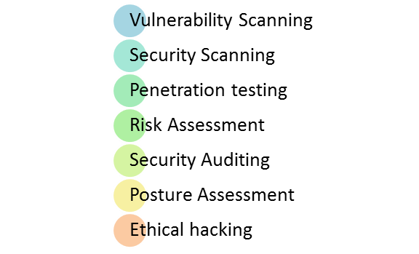

* Vulnerability Scanning : Is a process to find a vulnerability from security before it got founded by the attacker.
* Security Scanning : Is a Process to scan a system network for vulnerabilities like open ports or outdated software.
* Penetration Testing: Is a Simulation attack to the system to find a potential entry point that attacker could exploit.
* Risk Assessment : identifying and evaluating potential risk to the system including technical and non-technical factor.
* Security Auditing : is an internal inspection via line by line inspection of code for security law.
* Posture Assessment : combination of ethical hacking and risk assessment.
* Ethical Hacking : it’s an hacking organization that only exposing security flaw in the system.

**(b) Among test strategies, how to carry security testing.**

To test Cars Sales Portal security, by using Risk assessment Organizing risks into three categories will facilitate risk reduction.

**(c) Test phases in security testing**

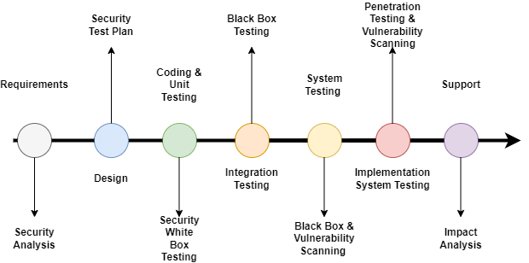

During the Requirement phase, security must analyze the requests and check for any abuse cases. During the Design Phase, security will analyze for the design. For Coding and Unit Testing Phase, use static, dynamic and white box testing. In the Integration Phase, the testing that will be used is black box testing. During the System Phase, black box testing and vulnerability scanning will be used. Penetration testing and vulnerability scanning will be used in Implementation System Phase. The final Phase is Support, analyzing the impact of patches.

**2. Develop the detailed test plan with test cases based on quantitative risk analysis**

**Quantitative Risk Analysis**

The followings must be used to develop test plan.

1. Functional Testing - UAT test cases

2. Compatibility - Cross-browser testing / responsiveness

3. Performance Efficiency - Load Testing/ Stress testing

4. Usability testing - Prototyping

5. Security - Security testing (IU 5) / Spring Security **(Priority Testing)**

(a) SQL injection

(b) Logging

(c) Authentication and Authorization

6. Portability - Multi platforms (different platforms, different devices)

7. Reliability – **same with usability testing**

8. Maintainability – Using Spring (Dependency Injection), Junit Testing

The learner need to create test plan **with table in the following criteria.**

**Test Plan (Security testing must be priority in your plan)**

- Test Scenario

- Test Cases (Under one scenario, there may be more than one test cases)

- Test Objectives

- Expected Outcome

- Risk

- Techniques (Types of testing)

|  |  |  |  |  |  |  |  |
| --- | --- | --- | --- | --- | --- | --- | --- |
| Risk ID | Test Scenario Id | Test Scenario | Test Objective | Test Priority | Risk | Technique | Expected Result |
| 1 | TS001 | Check if the car data inserted in database | To ensure if the data inserted to database or not | High | If the data isn’t inserted the car cannot be displayed in carlist page | Functional Testing | The data is inserted to the database |
| 2 | TS002 | Check if the user data from database changed after user change it in website | To ensure if the data updated to database or not | High | If the new data isn’t inserted the user new data isn’t updated | Functional Testing | The data is Updated to the database |
| 3 | TS003 | Check if view detail button really go to view detail page | To ensure if the link really go to the right place | Medium | User can’t see car detail information | Functional Testing | The button goes to view detail page |
| 4 | TS004 | Check if the search really search based on what user search | To ensure if the data displayed properly | Low | User can’t see the car they looking for. | Functional Testing | The search result page |
| 5 | TS005 | Check if the add car and add bid car button go to their page. | To ensure if the link really go to the right place | Medium | User can’t sale their car. | Functional Testing | Both of the button go to their page |
| 6 | TS006 | Check if the website look the same in another browser | To ensure the look of the website doesn’t change | Medium | Users feel dissatisfied . | Compatibility Testing | It look the same in other browser |
| 7 | TS007 | Car listing page work under two second | To make sure user doesn’t wait to long | High | Users feel dissatisfied . | Performance  Testing | It work under two second |
| 8 | TS008 | Check if the login form throws an error if the user input is wrong. | To give user proper massage when error come | High | User confuse because they don’t know if there are an error on their input | Usability Testing | It throw an error |
| 9 | TS009 | Check if the administration panel only can be accessed by admin role | To keep the website data secured | High | Data loss | Security Testing | Other than admin role get forbidden exception |
| 10 | TS0010 | Check if the website can still be used in different device | To let the website accessible in different device | High | Mobile user cannot access the website | Portability Testing | The website can be accessed in mobile and tablet too. |
| 11 | TS0011 | Check if the code can be readed by other developer | To not make other developer confused. | Low | Hard to maintaining the website | Maintainability  testing | The code has given many comments. |

**3. Create a test risk matrix with the evaluation of the impact**

How Risk Evaluation is conducted.

Identify the risk.

Asses the risk.

Evaluate the risk.

Develop risk response strategy.

Implement and monitor the response strategy.

Develop a test Risk Matrix for a given specification.

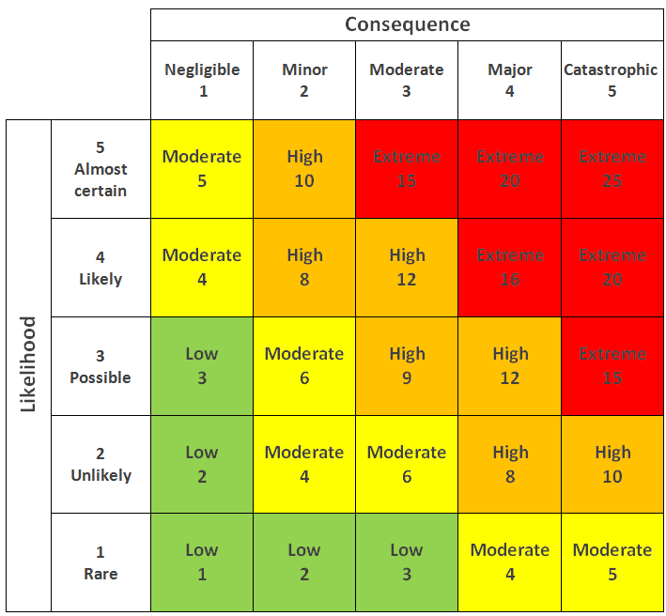

|  |  |  |  |  |  |  |
| --- | --- | --- | --- | --- | --- | --- |
| Risk ID | Risk | Likelihood  (1-5) | Impact  (1 – 5) | Type of  Testing | Risk  Rating | Risk Level |
| 1 | the data isn’t inserted to the database | 2 | 5 | Functional Testing | 10 | High |
| 2 | The data isn’t updated in the database | 2 | 5 | Functional Testing | 10 | High |
| 3 | User can’t see the page supposed to be | 2 | 3 | Functional Testing | 6 | Moderate |
| 4 | User can’t see the car they want | 3 | 1 | Functional Testing | 3 | Low |
| 5 | User can’t sale their car | 2 | 3 | Functional Testing | 6 | Moderate |
| 6 | The website look different in other browser | 4 | 1 | Compatibility Testing | 4 | Moderate |
| 7 | User wait longer | 3 | 3 | Performance  Testing | 9 | High |
| 8 | Miss communication between user and the website | 4 | 3 | Usability Testing | 12 | High |
| 9 | Data loss | 5 | 5 | Security Testing | 25 | High |
| 10 | The website cannot be accessed in different device | 4 | 3 | Portability Testing | 12 | High |
| 11 | Hard to maintain the website | 2 | 1 | Maintainability  testing | 2 | Low |

1. Task 5

Task Statement

Create the following items under “Testing Strategy” in Project Report

1. Design suitable RBT cycle content and priorities further test cycles
2. Communicate the details of the strategy and test planning to the key stakeholders with proper justifications

Solution

* 1. Design suitable RBT cycle content and priorities further test cycles.

The suitable risk base test cycle for Cars Sales Portal is look like picture below.

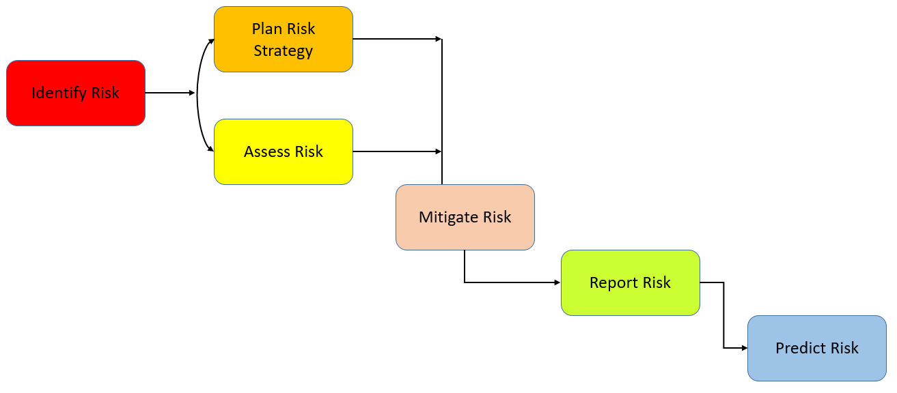

1. Identify Risk

The first step is to indentify the potential risk that might happen in Cars Sales Portal. Common risk that potentially happen is security risk,funtional risk, usability risk,compatibility risk, and performance risk.

1. Plan Risk Strategy and Assess Risk

Once the risk identified the next step is to spell out risk likelihood and the impact and sort the by three categories High, medium, and Low.

1. Mitigate Risk

This step will procees to find out how to dealing with those risk.

1. Report Risk

This step will process to documenting each risk that have been found.

1. Predict Risk

In this step will procees to predicting a potential risk in future before the risk a threat.

1. Communicate the details of the strategy and test planning to the key stakeholders with proper justifications

1. Justify the selection of test methods based on quantified risk to a project.

|  |  |
| --- | --- |
| **Type of Testing** | **Main Purpose** |
| Functional Testing | This testing pupose is to verifies if the system or application work as per defined functional requirement. |
| Compatibility Testing | This testing pupose is to verifies that the apllication can work in different environtment like browser or device. |
| Usability Testing | This testing pupose is to verifies if the apllication is easy to use, and user friendly. |
| Security Testing | This testing pupose is to make sure if the system and application is secured. |
| Portablity Testing | This testing pupose is to ensure the application and syastem can be transferred to another environtment without issues |
| Maintainability Testing | This testing pupose is to ensure the application can be maintain easily |

1. Communicate the details of your strategy and test planning to the key stakeholders with proper justifications

* Get to know the Stakeholder

Before start to the Risk issue, take time to get to know the stakeholder interest,priority and concern.

* Talk about Risk Impact

When communicating about the strategy and test planning its important to explain how the testing will help to reduce the impact of the risk.

* Communicate Early and often

Keep the stakeholder well infromed about the project by giving regular update about testing progress.

* Create an alert

Create an alert to notify the stakeholder of any risk that come during testing.

1. Task 6

Task Statement:

Create the following items under **“Testing Results”** in Project Report

1. Execute the risk-based test plan and log the test results

2. Modify the risk-based test procedure with the reasons

Solution :

1. Execute the risk-based test pan and log the test results.

1. UAT Test

Registration

|  |  |
| --- | --- |
| Test Scenario | Registration |
| TS001 |
| Test Cases | Registration in Cars Sales Portal |
| TC001 | Validating data that has entered into registration page |
| TC002 | Once data has entered it should save the data into database |

|  |  |  |  |  |  |  |
| --- | --- | --- | --- | --- | --- | --- |
| Test Scenario ID | Test Case ID | Test Priority | Pre-condition | Expected Result | Actual Result | Pass/  Fail |
| TS001 | TC001 | Moderate | Any user can access the website | A massage will appear when the input is wrong | The massage is appear | Pass |
| TC002 | High | The information that user put in the for inserted to the databae | The information is inserted to the database | Pass |
| Test Step & Test data | TC001 | In Registration Page, insert :  1. Name: Adi  2. Email: adi.com  3. Password: 123  6. Click Register button | | | | |
| TC002 | In Registration Page, insert :  1. Name: Adi  2. Email: adi@gmail.com  3. Password: 123  6. Click Register button | | | | |
| Evidence | **Refer SS- SS01** | | | | | |
| **Refer SS-SS02** | | | | | |

Login

|  |  |
| --- | --- |
| Test Scenario | Login |
| TS002 |
| Test Cases | Login in Cars Sales Portal |
| TC001 | User not found |
| TC002 | Once successfully login the name that display in the navbar should be the user currently login |

|  |  |  |  |  |  |  |
| --- | --- | --- | --- | --- | --- | --- |
| Test Scenario ID | Test Case ID | Test Priority | Pre-condition | Expected Result | Actual Result | Pass/  Fail |
| TS002 | TC001 | Moderate | Any user can access the website | A massage will appear when the user is not found | The massage is appear | Pass |
| TC002 | Moderate | After successful login | User name will appear in the navbar | User name appear in the navbar | Pass |
| Test Step & Test data | TC001 | In the Login page, insert :  1.Name : Adi  2. Password : 122  3. Click Login | | | | |
| TC002 | In the Login page, insert :  1.Name : Adi  2. Password : 123  3. Click Login | | | | |
| Evidence | **Refer SS- SS01** | | | | | |
| **Refer SS-SS02** | | | | | |

Search

|  |  |
| --- | --- |
| Test Scenario | Search |
| TS003 |
| Test Cases | Search Car in Cars Sales Portal |
| TC001 | Check if the page search form will go is Search Result page |
| TC002 | the car will display like what user type in the search input |

|  |  |  |  |  |  |  |
| --- | --- | --- | --- | --- | --- | --- |
| Test Scenario ID | Test Case ID | Test Priority | Pre-condition | Expected Result | Actual Result | Pass/  Fail |
| TS003 | TC001 | Moderate | Any user can access the website | The form will go to search result page | The form action is going to search result page | Pass |
| TC002 | Moderate | Any user can access the website, the car what user search is exist | The car displayed like what user type | The displayed car is likely what user search for | Pass |
| Test Step & Test data | TC001 | In the search form, insert “Tesla” and click Search | | | | |
| TC002 |
| Evidence | **Refer SS- SS01** | | | | | |
| **Refer SS-SS02** | | | | | |

View Car

|  |  |
| --- | --- |
| Test Scenario | View Car |
| TS004 |
| Test Cases | Display Car List in Cars Sales Portal |
| TC001 | Car List Page will display all car in database |
| TC002 | View detail button will display car detail information |

|  |  |  |  |  |  |  |
| --- | --- | --- | --- | --- | --- | --- |
| Test Scenario ID | Test Case ID | Test Priority | Pre-condition | Expected Result | Actual Result | Pass/  Fail |
| TS004 | TC001 | Moderate | Any user can access the website, the car is exist | Carlist page will display every car in database | The page displaying all car | Pass |
| TC002 | Moderate | Any user can access the website, the car is exist | The view detail button will go to car detail page | The button action go to car detail page | Pass |
| Test Step & Test data | TC001 | In the home page click car list menu in navbar | | | | |
| TC002 | In the car list page click view detail button | | | | |
| Evidence | **Refer SS- SS01** | | | | | |
| **Refer SS-SS02** | | | | | |

Post Car

|  |  |
| --- | --- |
| Test Scenario | Post Car |
| TS005 |
| Test Cases | Post a car in Cars Sales Portal |
| TC001 | The image when post a is stored in project directory |
| TC002 | The data of the car is stored in database |

|  |  |  |  |  |  |  |
| --- | --- | --- | --- | --- | --- | --- |
| Test Scenario ID | Test Case ID | Test Priority | Pre-condition | Expected Result | Actual Result | Pass/  Fail |
| TS005 | TC001 | Moderate | User need to login | The image is stored in project directory | The image is stored in project directory | Pass |
| TC002 | High | User need to Log in | The data is stored in database | The data is stored in database | Pass |
| Test Step & Test data | TC001 | 1.Go to My Store Page  2.Click Sale a Car  3.Fill the form and select image  4.click submit | | | | |
| TC002 |
| Evidence | **Refer SS- SS01** | | | | | |
| **Refer SS-SS02** | | | | | |

1. Unit Testing

**Registration**

|  |  |
| --- | --- |
| Test Scenario | Registration Page |
| TS006 |
| Test Cases | Registration Functionality |
| TC001 | The data from registration form should be inserted to the database |

|  |  |  |  |  |  |  |
| --- | --- | --- | --- | --- | --- | --- |
| Test Scenario ID | Test Case ID | Test Priority | Pre-condition | Expected Result | Actual Result | Pass/  Fail |
| TS006 | TC001 | High | Any user can access the website | The data should be inserted to the database | Something wrong with password encoder | Fail |
| Test Step & Test data | TC001 | 1.Create Registration Method  2.create new object user with user data inside of it.  3.use service to insert the data  4.run test cases | | | | |
| Evidence | **Refer SS- SS01** | | | | | |

**Login**

|  |  |
| --- | --- |
| Test Scenario | Login Page |
| TS007 |
| Test Cases | Login Functionality |
| TC001 | Successfully Login |

|  |  |  |  |  |  |  |
| --- | --- | --- | --- | --- | --- | --- |
| Test Scenario ID | Test Case ID | Test Priority | Pre-condition | Expected Result | Actual Result | Pass/  Fail |
| TS007 | TC001 | High | Any user can access the website | Success login using existing data from database | Success login using existing data | pass |
| Test Step & Test data | TC001 | 1.Create Login Method  2.create new object user with existed user data inside of it.  3.use service to check user data  4.run test cases | | | | |
| Evidence | **Refer SS- SS01** | | | | | |

**Search Car**

|  |  |
| --- | --- |
| Test Scenario | Search Page |
| TS008 |
| Test Cases | Search Functionality |
| TC001 | Search for a Car |

|  |  |  |  |  |  |  |
| --- | --- | --- | --- | --- | --- | --- |
| Test Scenario ID | Test Case ID | Test Priority | Pre-condition | Expected Result | Actual Result | Pass/  Fail |
| TS008 | TC001 | Moderate | Any user can access the website | Display the searched car | Car not founded | Fail |
| Test Step & Test data | TC001 | 1.Create Search Method  2.create new object car.  3.use service to search car.  4.run test cases | | | | |
| Evidence | **Refer SS- SS01** | | | | | |

**View Car**

|  |  |
| --- | --- |
| Test Scenario | View Car Page |
| TS009 |
| Test Cases | View Car Functionality |
| TC001 | Display |

|  |  |  |  |  |  |  |
| --- | --- | --- | --- | --- | --- | --- |
| Test Scenario ID | Test Case ID | Test Priority | Pre-condition | Expected Result | Actual Result | Pass/  Fail |
| TS009 | TC001 | Moderate | Any user can access the website | List of car appear | List of car appear | Pass |
| Test Step & Test data | TC001 | 1.Create View Car Method  2.create new list of object with car data inside of it.  3.use service to display them all  4.run test cases | | | | |
| Evidence | **Refer SS- SS01** | | | | | |

**Post Car**

|  |  |
| --- | --- |
| Test Scenario | Post Car |
| TS010 |
| Test Cases | Post Functionality |
| TC001 | Post a car |

|  |  |  |  |  |  |  |
| --- | --- | --- | --- | --- | --- | --- |
| Test Scenario ID | Test Case ID | Test Priority | Pre-condition | Expected Result | Actual Result | Pass/  Fail |
| TS010 | TC001 | High | Login using account that have user role | Car data got inserted to database | Car data got inserted to database | Pass |
| Test Step & Test data | TC001 | 1.Create post car Method  2.create new car object and give some value.  3.use service to insert the data  4.run test cases | | | | |
| Evidence | **Refer SS- SS01** | | | | | |

1. Permormance Testing

|  |  |
| --- | --- |
| Test Scenario | Performance Test |
| TS011 |
| Test Cases | Load test of Cars Sales Portal |
| TC001 | Test Case Speed |
| TC002 | Website Performace |

|  |  |  |  |  |  |  |
| --- | --- | --- | --- | --- | --- | --- |
| Test Scenario ID | Test Case ID | Test Priority | Pre-condition | Expected Result | Actual Result | Pass/  Fail |
| TS011 | TC001 | Moderate | The website is published | The page load below 2 second | The page speed is 30 ms | Pass |
| TC002 | The performace should be above 80 | The performance is 99 |
| Test Step & Test data | TC001 | Right click on the website > click network | | | | |
| TC002 | Right click on the website > click lighthouse > analyze page load | | | | |
| Evidence | **Refer SS- SS01** | | | | | |
| **Refer SS- SS02** | | | | | |

1. Compatibility Testing

Registration Page

|  |  |
| --- | --- |
| Test Scenario | Cross browser register test |
| TS012 |
| Test Cases | Register in Cars Sales Portal in three browser |
| TC001 | Run Cars Sales Portal in Chrome |
| TC002 | Run Cars Sales Portal in Firefox |
| TC003 | Run Cars Sales Portal in Microsoft Edge |

|  |  |  |  |  |  |  |
| --- | --- | --- | --- | --- | --- | --- |
| Test Scenario ID | Test Case ID | Test Priority | Pre-condition | Expected Result | Actual Result | Pass/  Fail |
| TS012 | TC001 | Low | The website is published | The view is same in every browser | They look the same | Pass |
| TC002 |
| TC003 |
| Test Step & Test data | TC001 | Access localhost:8080/register in Chrome | | | | |
| TC002 | Access localhost:8080/register in Firefox | | | | |
| TC003 | Access localhost:8080/register in Microsoft Edge | | | | |
| Evidence | **Refer SS- SS01** | | | | | |
| **Refer SS- SS02** | | | | | |
| **Refer SS- SS03** | | | | | |

Login Page

|  |  |
| --- | --- |
| Test Scenario | Cross browser login test |
| TS013 |
| Test Cases | Login in Cars Sales Portal in three browser |
| TC001 | Run Cars Sales Portal in Chrome |
| TC002 | Run Cars Sales Portal in Firefox |
| TC003 | Run Cars Sales Portal in Microsoft Edge |

|  |  |  |  |  |  |  |
| --- | --- | --- | --- | --- | --- | --- |
| Test Scenario ID | Test Case ID | Test Priority | Pre-condition | Expected Result | Actual Result | Pass/  Fail |
| TS013 | TC001 | Low | The website is published | The view is same in every browser | They look the same | Pass |
| TC002 |
| TC003 |
| Test Step & Test data | TC001 | Access localhost:8080/login in Chrome | | | | |
| TC002 | Access localhost:8080/login in Firefox | | | | |
| TC003 | Access localhost:8080/login in Microsoft Edge | | | | |
| Evidence | **Refer SS- SS01** | | | | | |
| **Refer SS- SS02** | | | | | |
| **Refer SS- SS03** | | | | | |

Search Page

|  |  |
| --- | --- |
| Test Scenario | Cross browser search test |
| TS014 |
| Test Cases | Use search in Cars Sales Portal in three browser |
| TC001 | Run Cars Sales Portal in Chrome |
| TC002 | Run Cars Sales Portal in Firefox |
| TC003 | Run Cars Sales Portal in Microsoft Edge |

|  |  |  |  |  |  |  |
| --- | --- | --- | --- | --- | --- | --- |
| Test Scenario ID | Test Case ID | Test Priority | Pre-condition | Expected Result | Actual Result | Pass/  Fail |
| TS014 | TC001 | Low | The website is published | The view is same in every browser | They look the same | Pass |
| TC002 |
| TC003 |
| Test Step & Test data | TC001 | Type car’s make or model in search form | | | | |
| TC002 |
| TC003 |
| Evidence | **Refer SS- SS01** | | | | | |
| **Refer SS- SS02** | | | | | |
| **Refer SS- SS03** | | | | | |

View Page

|  |  |
| --- | --- |
| Test Scenario | Cross browser Car listing test |
| TS015 |
| Test Cases | Display cars list in Cars Sales Portal in three browser |
| TC001 | Run Cars Sales Portal in Chrome |
| TC002 | Run Cars Sales Portal in Firefox |
| TC003 | Run Cars Sales Portal in Microsoft Edge |

|  |  |  |  |  |  |  |
| --- | --- | --- | --- | --- | --- | --- |
| Test Scenario ID | Test Case ID | Test Priority | Pre-condition | Expected Result | Actual Result | Pass/  Fail |
| TS015 | TC001 | Low | The website is published | The view is same in every browser | They look the same | Pass |
| TC002 |
| TC003 |
| Test Step & Test data | TC001 | Access localhost:8080/carlist in Chrome | | | | |
| TC002 | Access localhost:8080/carlist in Firefox | | | | |
| TC003 | Access localhost:8080/carlist in Microsoft Edge | | | | |
| Evidence | **Refer SS- SS01** | | | | | |
| **Refer SS- SS02** | | | | | |
| **Refer SS- SS03** | | | | | |

Post Car Page

|  |  |
| --- | --- |
| Test Scenario | Cross browser post car test |
| TS016 |
| Test Cases | Post a car in Cars Sales Portal in three browser |
| TC001 | Run Cars Sales Portal in Chrome |
| TC002 | Run Cars Sales Portal in Firefox |
| TC003 | Run Cars Sales Portal in Microsoft Edge |

|  |  |  |  |  |  |  |
| --- | --- | --- | --- | --- | --- | --- |
| Test Scenario ID | Test Case ID | Test Priority | Pre-condition | Expected Result | Actual Result | Pass/  Fail |
| TS016 | TC001 | Low | The website is published | The view is same in every browser | They look the same | Pass |
| TC002 |
| TC003 |
| Test Step & Test data | TC001 | Log in using user role account, click Sale car button or sale bid car button in my store page, fill the form and click submit. | | | | |
| TC002 |
| TC003 |
| Evidence | **Refer SS- SS01** | | | | | |
| **Refer SS- SS02** | | | | | |
| **Refer SS- SS03** | | | | | |

1. Porbality Testing

|  |  |
| --- | --- |
| Test Scenario | Portability Test |
| TS017 |
| Test Cases | Open Cars Sales Portal in three Device |
| TC001 | Run Cars Sales Portal in Desktop/Laptop |
| TC002 | Run Cars Sales Portal in Tablet |
| TC003 | Run Cars Sales Portal in Mobile |

|  |  |  |  |  |  |  |
| --- | --- | --- | --- | --- | --- | --- |
| Test Scenario ID | Test Case ID | Test Priority | Pre-condition | Expected Result | Actual Result | Pass/  Fail |
| TS017 | TC001 | Low | The website is published | Cars sales portal still working in three different device | Cars sales portal is working in three different device | Pass |
| TC002 |
| TC003 |
| Test Step & Test data | TC001 | Open Cars Sales Portal in Desktop or Laptop | | | | |
| TC002 | Open Cars Sales Portal in Tablet | | | | |
| TC003 | Open Cars Sales Portal in Mobile | | | | |
| Evidence | **Refer SS- SS01** | | | | | |
| **Refer SS- SS02** | | | | | |
| **Refer SS- SS03** | | | | | |

1. Usability Testing

Register

|  |  |
| --- | --- |
| Test Scenario | Usability test of registering in Cars Sales Portal |
| TS018 |
| Test Cases | Register in Cars Sales Portal |
| TC001 | User need to register in cars sales portal |

|  |  |  |  |  |  |  |
| --- | --- | --- | --- | --- | --- | --- |
| Test Scenario ID | Test Case ID | Test Priority | Pre-condition | Expected Result | Actual Result | Pass/  Fail |
| TS018 | TC001 | low | Any user can access the website | User should be able to register | Users can register without issue | Pass |
| Test Step & Test data | TC001 | 1.go to cars sales portal  2.click login button  3.click don’t have account  4.fill the form and click submit | | | | |
| Evidence | **Refer SS- SS01** | | | | | |

Login

|  |  |
| --- | --- |
| Test Scenario | Usability test of login in Cars Sales Portal |
| TS019 |
| Test Cases | Login in Cars Sales Portal |
| TC001 | User need to login in cars sales portal |

|  |  |  |  |  |  |  |
| --- | --- | --- | --- | --- | --- | --- |
| Test Scenario ID | Test Case ID | Test Priority | Pre-condition | Expected Result | Actual Result | Pass/  Fail |
| TS019 | TC001 | low | Any user can access the website | User should be able to login | Users can login without issue | Pass |
| Test Step & Test data | TC001 | 1.go to cars sales portal  2.click login button  3. fill the form and click submit | | | | |
| Evidence | **Refer SS- SS01** | | | | | |

Search

|  |  |
| --- | --- |
| Test Scenario | Usability test of Search of a car in Cars Sales Portal |
| TS020 |
| Test Cases | Search a car in Cars Sales Portal |
| TC001 | User need to Search a car in cars sales portal |

|  |  |  |  |  |  |  |
| --- | --- | --- | --- | --- | --- | --- |
| Test Scenario ID | Test Case ID | Test Priority | Pre-condition | Expected Result | Actual Result | Pass/  Fail |
| TS020 | TC001 | low | Any user can access the website | User should be able to search a car | Users can search a car without issue | Pass |
| Test Step & Test data | TC001 | 1.go to cars sales portal  2. type cars make or model in the search form  3. click search | | | | |
| Evidence | **Refer SS- SS01** | | | | | |

View Car

|  |  |
| --- | --- |
| Test Scenario | Usability test of liast all car in Cars Sales Portal |
| TS021 |
| Test Cases | List all car in Cars Sales Portal |
| TC001 | User need to see list all car in cars sales portal |

|  |  |  |  |  |  |  |
| --- | --- | --- | --- | --- | --- | --- |
| Test Scenario ID | Test Case ID | Test Priority | Pre-condition | Expected Result | Actual Result | Pass/  Fail |
| TS021 | TC001 | low | Any user can access the website | User should be able to go to car list page | Users can go to car list page without issue | Pass |
| Test Step & Test data | TC001 | 1.go to cars sales portal  2. go to car list page by click car list button in the navbar  3. click search | | | | |
| Evidence | **Refer SS- SS01** | | | | | |

Post Car

|  |  |
| --- | --- |
| Test Scenario | Usability test of post a car in Cars Sales Portal |
| TS022 |
| Test Cases | post a carin Cars Sales Portal |
| TC001 | User need to post a carin cars sales portal |

|  |  |  |  |  |  |  |
| --- | --- | --- | --- | --- | --- | --- |
| Test Scenario ID | Test Case ID | Test Priority | Pre-condition | Expected Result | Actual Result | Pass/  Fail |
| TS022 | TC001 | low | Any user can access the website | User should be able to post a car | Users can post a car without issue | Pass |
| Test Step & Test data | TC001 | 1.go to cars sales portal  2. login as user role account  2. click my store button in the navbar dropdown  3. click sale a car button  4. fill the form and click submit | | | | |
| Evidence | **Refer SS- SS01** | | | | | |

1. Security Testing

|  |  |
| --- | --- |
| Test Scenario | Security Test |
| TS023 |
| Test Cases | Test the security of Cars Sales Portal |
| TC001 | Check if the user that currently login really exist in the database |
| TC002 | Validate user input in login page |
| TC003 | Check if user role can’t access adiministration panel |
| TC004 | Check if admin role can’t post a car |
| TC005 | Check if the input mustn’t have any special character for sql injection |

|  |  |  |  |  |  |  |
| --- | --- | --- | --- | --- | --- | --- |
| Test Scenario ID | Test Case ID | Test Priority | Pre-condition | Expected Result | Actual Result | Pass/  Fail |
| TS023 | TC001 | High | Any user can access the website | User input and data in database is matching | Both of the is matching | Pass |
| TC002 | Send error massage if user input is wrong | The massage is sended if the input is wrong |
| TC003 | The page will go to forbidden page | It go to forbidden page |
| TC004 |
| TC005 | If the input contain special char in will display error | If the input contain special char in will display error |
| Test Step & Test data | TC001 | 1.go to cars sales portal  2. click login button  3.fill the form and click submit | | | | |
| TC002 | 1. go to car sales portal  2.click login button  3.don’t fill the form and click submit | | | | |
| TC003 | 1. got to cars sales portal  2. login as user role  3. go to localhost:8080/list-of-user | | | | |
| TC004 | 1. got to cars sales portal  2. login as admin role  3. go to my store page | | | | |
| TC005 | 1. go to car sales portal  2.click login button  3.type special char in name input and click submit | | | | |
| Evidence | **Refer SS- SS01** | | | | | |
| **Refer SS- SS02** | | | | | |
| **Refer SS- SS03** | | | | | |
| **Refer SS- SS04** | | | | | |
| **Refer SS- SS05** | | | | | |

**Provide a detailed log of test results**

Show in tabular format with (test Name, comments, description, test result, start time, end time)

|  |  |
| --- | --- |
|  | **Used Car Sale Portal Project** |
|  |  |
| **Reported By:** | Kadek Adi Astawa |
| **Report Date:** | 2/16/2023 |
|  |  |
| **Tested By:** | I Kadek Adi Astawa |
| **Tested Date:** | 2/16/2023 |
| **Testing Name/ Test Scenario ID** | UAT Testing/ TS001 / TS002 / TS003 / TS004 /TS005 |
| **Total Number of Test Cases** | 10 |
| **No. of Pass:** | 10 |
| **No. of Failures:** | 0 |
| **Elapsed Time:** | 20 minutes |
|  |  |
| **Tested By:** | Kadek Adi Astawa |
| **Tested Date:** | 2/16/2023 |
| **Testing Name/ Test Scenario ID** | Unit Testing/ TS006 / TS007 / TS008 / TS009 / TS010 |
| **Total Number of Test Cases** | 5 |
| **No. of Pass:** | 3 |
| **No. of Failures:** | 2 |
| **Elapsed Time:** | 32 minutes |
|  |  |
| **Tested By:** | Kadek Adi Astawa |
| **Tested Date:** | 2/16/2023 |
| **Testing Name/ Test Scenario ID** | Performance Testing/ TS011 |
| **Total Number of Test Cases** | 2 |
| **No. of Pass:** | 2 |
| **No. of Failures:** | 0 |
| **Elapsed Time:** | 6 minutes |
|  |  |
| **Tested By:** | Kadek Adi Astawa |
| **Tested Date:** | 2/16/2023 |
| **Testing Name/ Test Scenario ID** | Compatibility Testing/ TS0012 / TS013 / TS014 / TS015 / TS016 |
| **Total Number of Test Cases** | 15 |
| **No. of Pass:** | 15 |
| **No. of Failures:** | 0 |
| **Elapsed Time:** | 20 minutes |
|  |  |
| **Tested By:** | Kadek Adi Astawa |
| **Tested Date:** | 2/16/2023 |
| **Testing Name/ Test Scenario ID** | Usability Testing/ TS018 / TS019 / TS020 / TS021 / TS022 |
| **Total Number of Test Cases** | 5 |
| **No. of Pass:** | 5 |
| **No. of Failures:** | 0 |
| **Elapsed Time:** | 12 minutes |
|  |  |
| **Tested By:** | Kadek Adi Astawa |
| **Tested Date:** | 2/16/2023 |
| **Testing Name/ Test Scenario ID** | Security Testing/ TS023 |
| **Total Number of Test Cases** | 5 |
| **No. of Pass:** | 5 |
| **No. of Failures:** | 0 |
| **Elapsed Time:** | 10 minutes |
|  |  |
| **Tested By:** | Kadek Adi Astawa |
| **Tested Date:** | 2/16/2023 |
| **Testing Name/ Test Scenario ID** | Portability Testing/ TS017 |
| **Total Number of Test Cases** | 3 |
| **No. of Pass:** | 3 |
| **No. of Failures:** | 0 |
| **Elapsed Time:** | 5 minutes |
| **SUMMARY LOG STATUS** | |
| **Total Number of Test Cases** | 45 |
| **Total Number of Pass** | 43 |
| **Total Number of Failures** | 2 |
| **Pass %** | 95.56% |
| **Total Elapsed Time** | 105 minutes |

2. Modify the risk-based test procedure with the reasons

**Techniques: Unit Testing (After Modify)**

**Search**

|  |  |
| --- | --- |
| Test Scenario | Search Page |
| TS008 |
| Test Cases | Search Functionality |
| TC001 | Search for a Car |

|  |  |  |  |  |  |  |
| --- | --- | --- | --- | --- | --- | --- |
| Test Scenario ID | Test Case ID | Test Priority | Pre-condition | Expected Result | Actual Result | Pass/  Fail |
| TS008 | TC001 | Moderate | Any user can access the website | Display the searched car | Car displayed like what user search | Pass |
| Test Step & Test data | TC001 | 1.Create Search Method  2.create new object car.  3.use service to search car.  4.run test cases | | | | |
| Evidence | **Refer SS- SS01** | | | | | |

Registration

|  |  |
| --- | --- |
| Test Scenario | Registration Page |
| TS006 |
| Test Cases | Registration Functionality |
| TC001 | The data from registration form should be inserted to the database |

|  |  |  |  |  |  |  |
| --- | --- | --- | --- | --- | --- | --- |
| Test Scenario ID | Test Case ID | Test Priority | Pre-condition | Expected Result | Actual Result | Pass/  Fail |
| TS006 | TC001 | High | Any user can access the website | The data should be inserted to the database | The data is stored in database | Pass |
| Test Step & Test data | TC001 | 1.Create Registration Method  2.create new object user with user data inside of it.  3.use service to insert the data  4.run test cases | | | | |
| Evidence | **Refer SS- SS01** | | | | | |

Log Result after modification

|  |  |
| --- | --- |
| **Project ID/ Project Name:** | **Used Car Sale Portal Project** |
|  |  |
| **Reported By:** | Kadek Adi Astawa |
| **Report Date:** | 2/16/2023 |
|  |  |
| **Tested By:** | Kadek Adi Astawa |
| **Tested Date:** | 2/16/2023 |
| **Testing Name/ Test Scenario ID** | UAT Testing/ TS006 / TS008 |
| **Total Number of Test Cases** | 2 |
| **No. of Pass:** | 2 |
| **No. of Failures:** | 0 |
| **Elapsed Time:** | 9 minutes |
| **SUMMARY LOG STATUS** | |
| **Total Number of Test Cases** | 2 |
| **Total Number of Pass** | 2 |
| **Total Number of Failures** | 0 |
| **Pass %** | 100% |
| **Total Elapsed Time** | 9minutes |

**Task 7**

Task statement :

Create the following items under **“Evaluation of Testing strategy”** in Project Presentation

1. Evaluate the effectiveness of the RBT strategy and assess the security testing cycles

2. Evaluate the testing strategies and compare it’s pro and cons

3. Assess the importance and environment suitability and examine the test heuristics are identified with proper justification

**Solution :**

**1. Evaluate the effectiveness of the RBT strategy and assess the security testing cycles.**

Evaluate and discuss the effectiveness of the RBT strategy after you applied it on the Car Portal.

1. Increase the effiency and effectiveness of testing
2. Reduce the time cost when doing a testing
3. Improve testing quality and productivity

Assess the security testing cycles.

1. In planing phase testing team need to identify security objective of the website.
2. In design phase testing team need to design security test based on the planning phase.
3. In implementation phase testing team will start do the testing.
4. In reporting phase testing team will report the result of the testing.

**2. Evaluate the testing strategies and compare it’s pro and cons**

The leaner needs to evaluate testing strategies that used in car portal and compare their pro and cons.

|  |  |
| --- | --- |
| **Before Using RBT** | |
| **Pro** | **Cons** |
| * Make tester more creative to identify the issue | * Time consuming |
| * Can be easily repeated and scaled | * Prone to human error |
| * Useful to finding user experience issue | * Can be difficult to maintain |

**3. Assess the importance and environment suitability and examine the test heuristics are identified with proper justification**

|  |  |
| --- | --- |
| **Environment** | **The Importance of Environment Suitability and How It Supports RBT Test Strategy** |
| STS IDE | To develop the website |
| MySQL Database | To create the database and table |
| Window 10 OS | To run the program |
| Java Version 17 | Programming language that used |
| ABC Cars Pte Ltd  (Used Car Sales Portal Application) | The project that need to be developed and tested |
| Test Plan | Testing that need to do to test the Website |
| Documentation | To documenting the devepoment process of the website |
| Devices | to test the website in different device |
| Browsers | To run the website |

**Task 8**

1. **Provide screen capture of developed pages** and hosted application in Project Presentation

Register

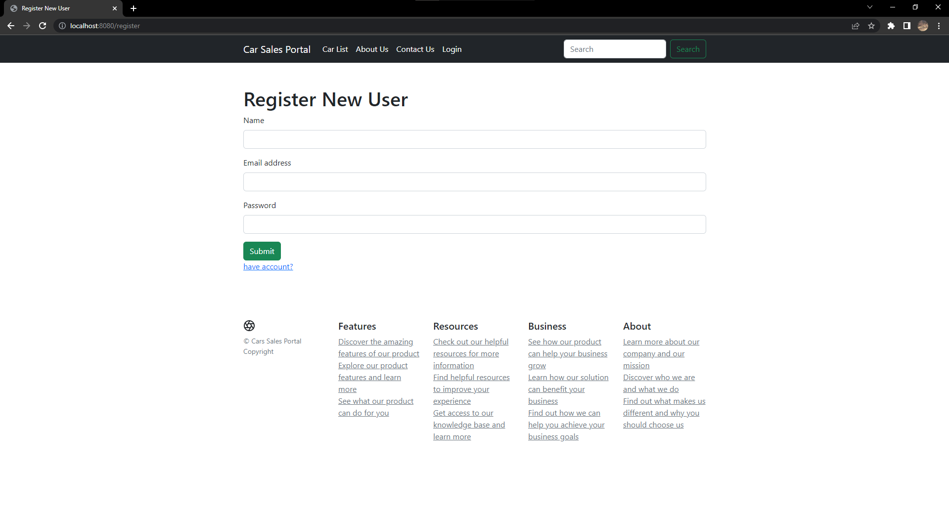

Login

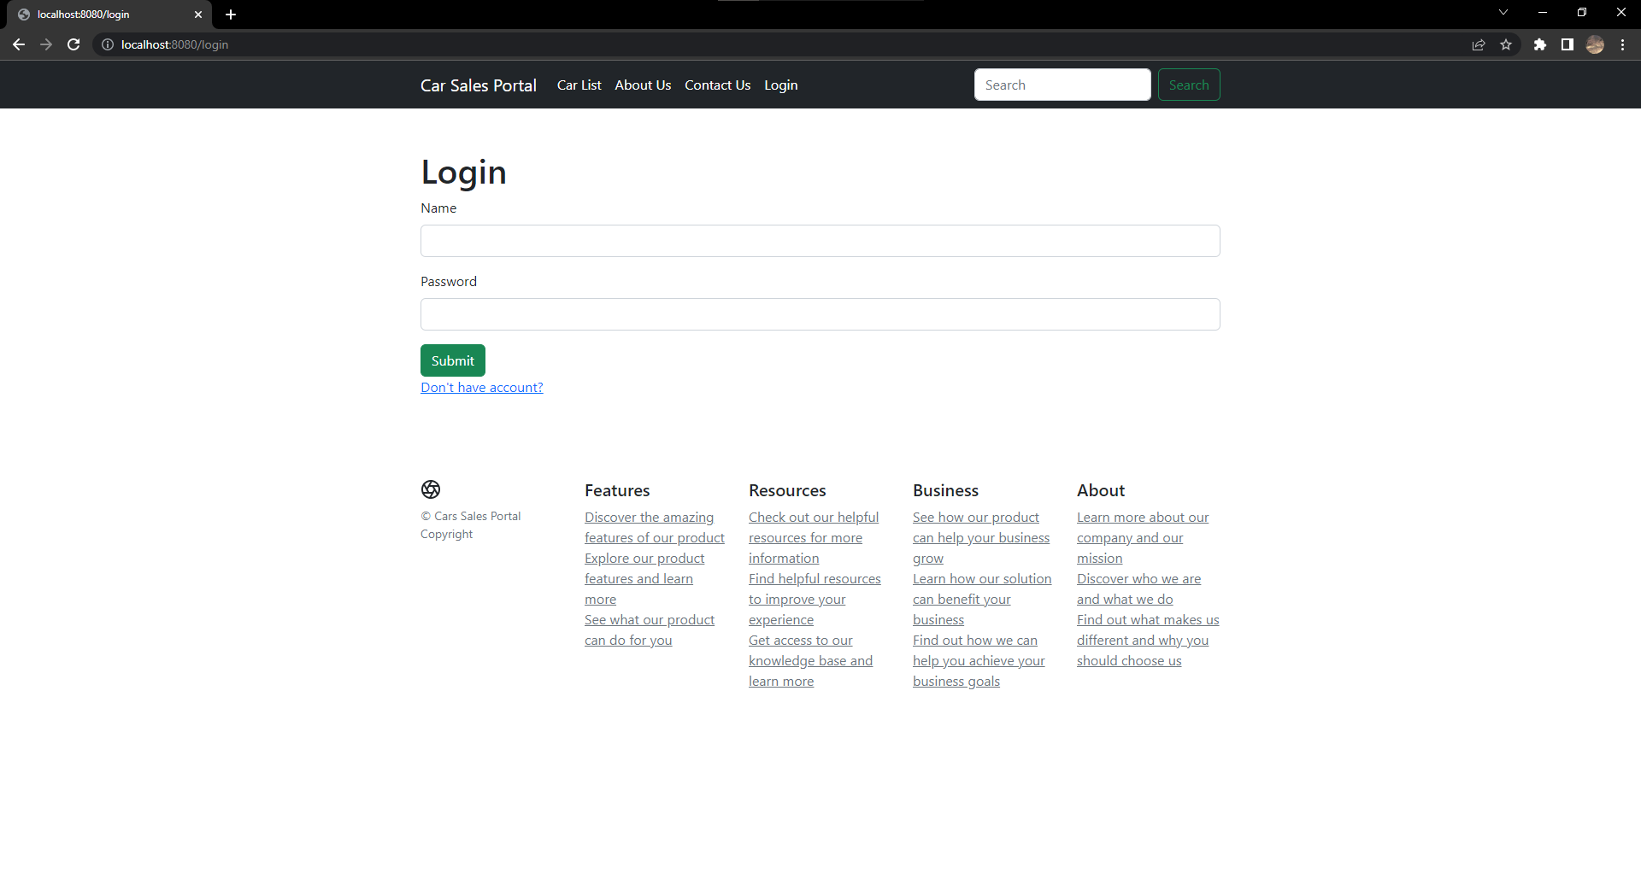

Home



About Us

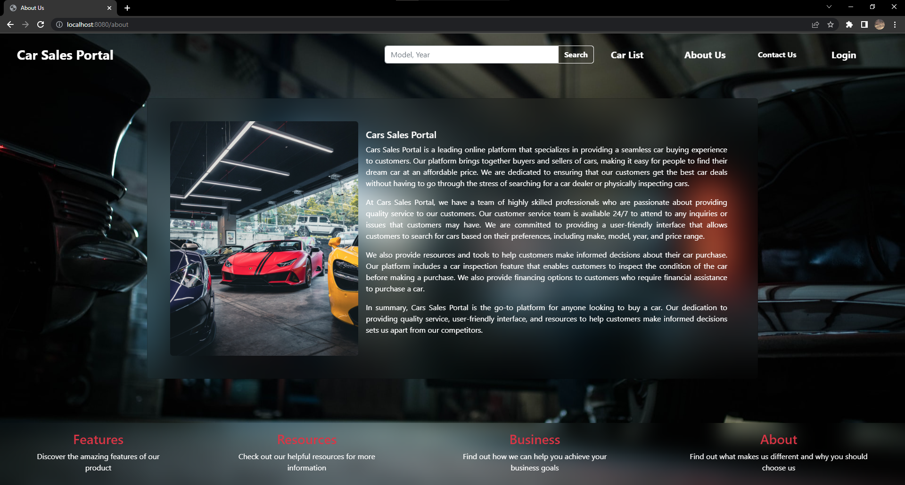

Contact Us

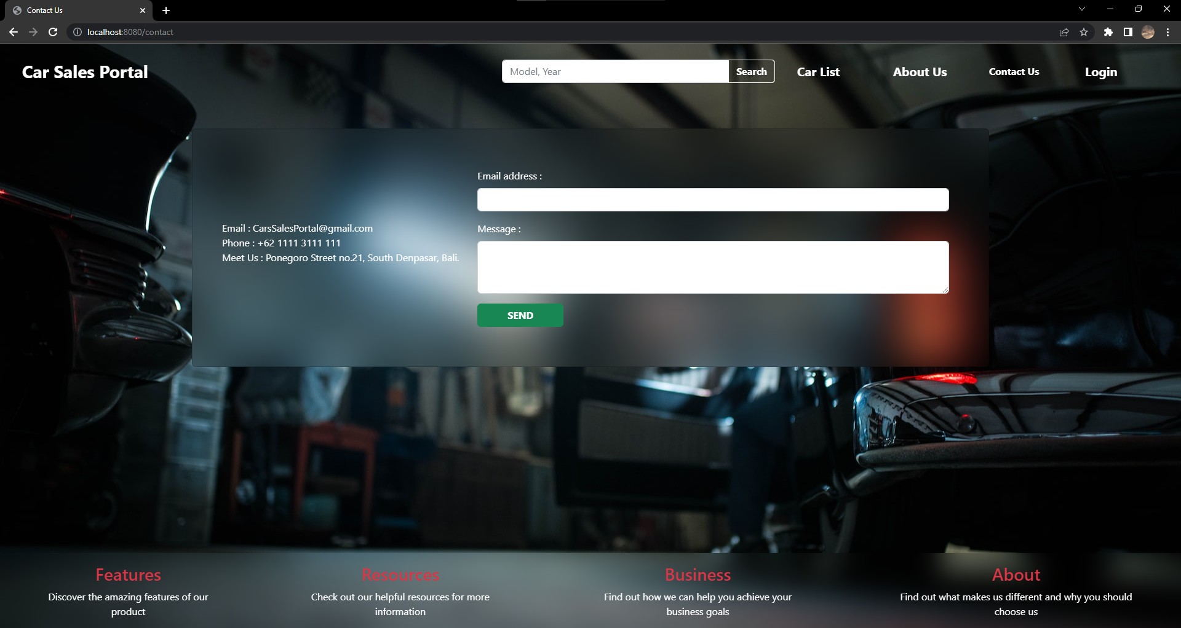

Search Result

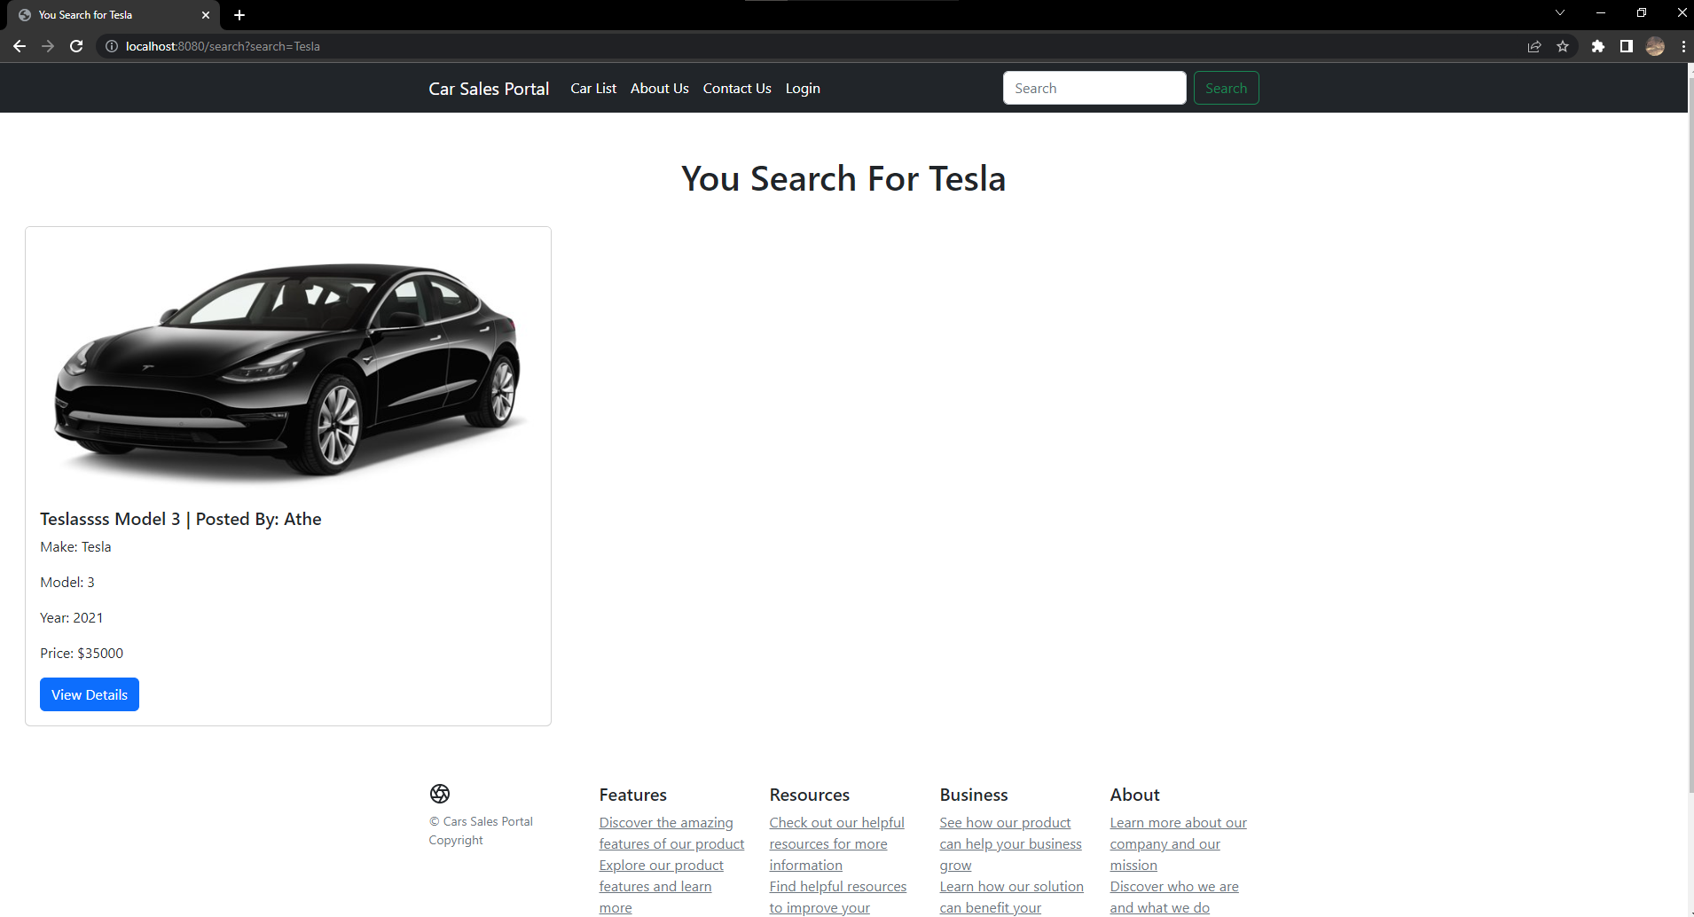

Car List

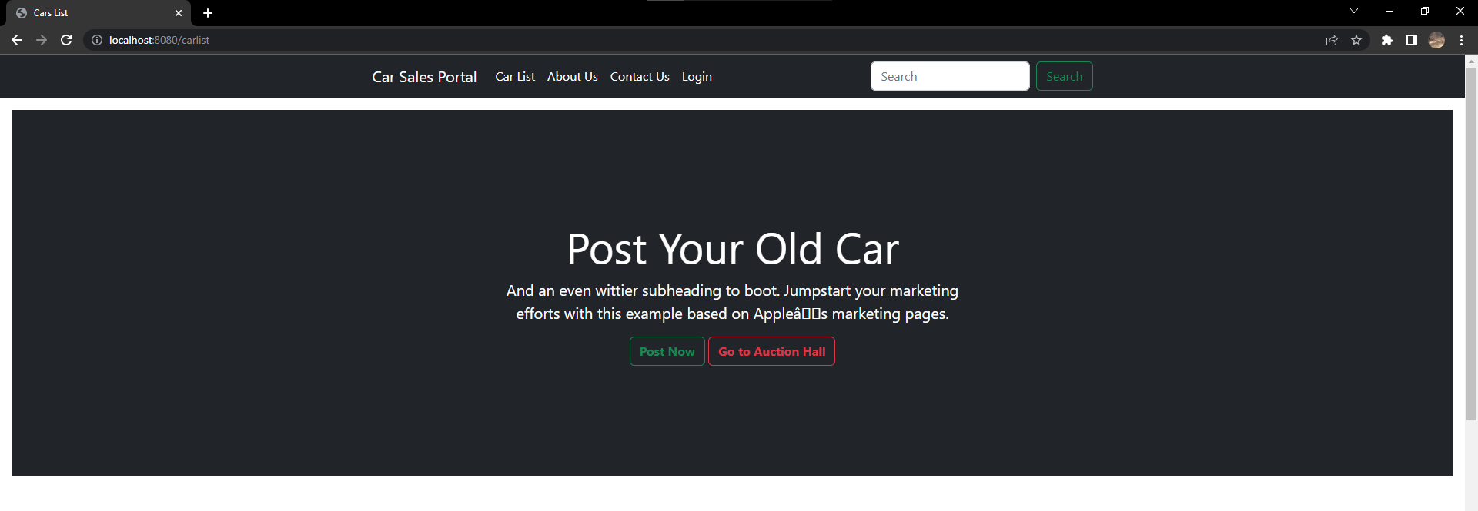

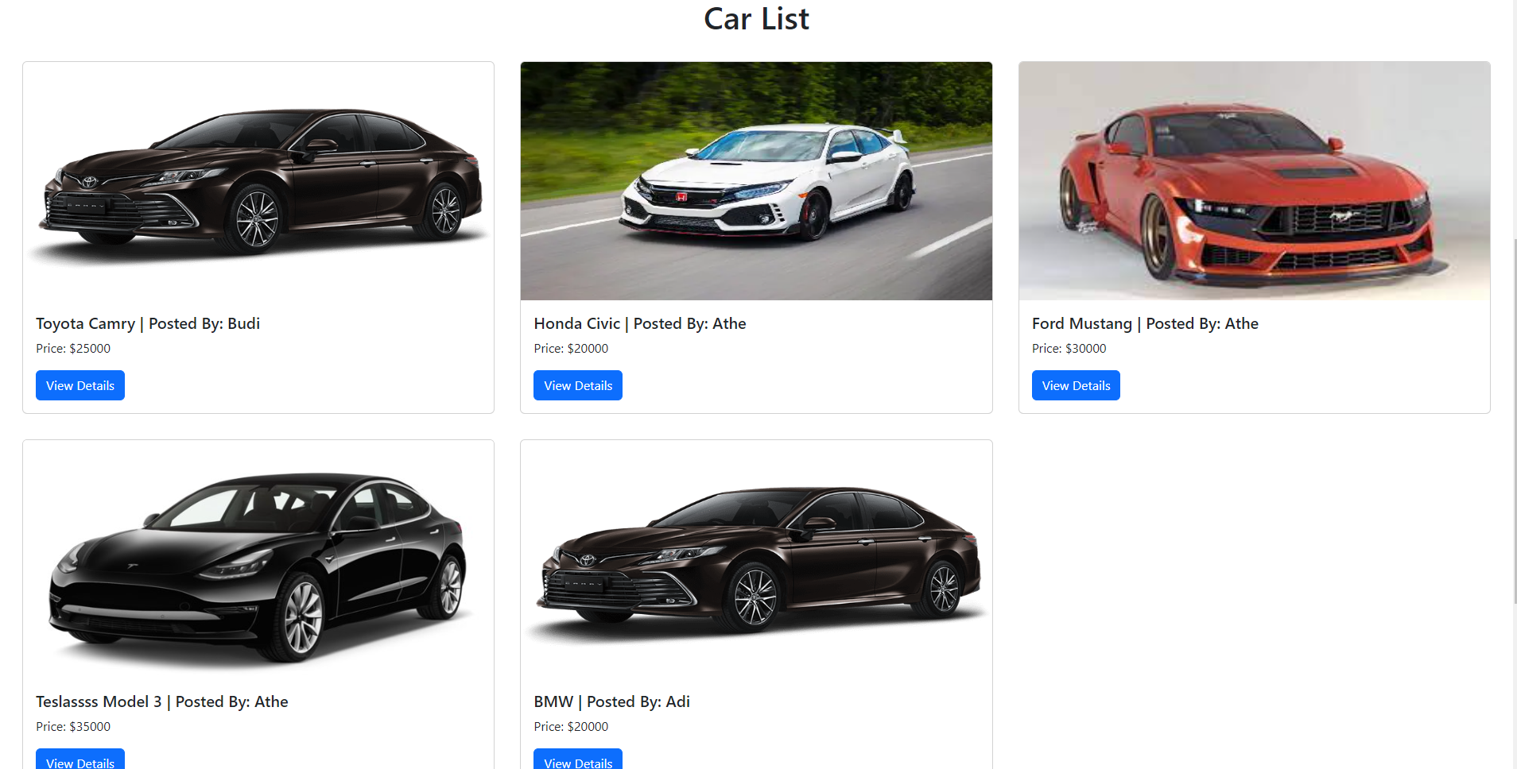

Auction Page

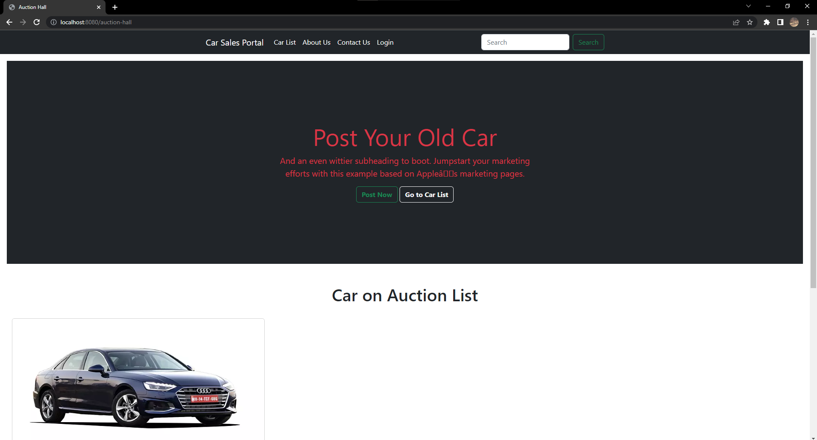

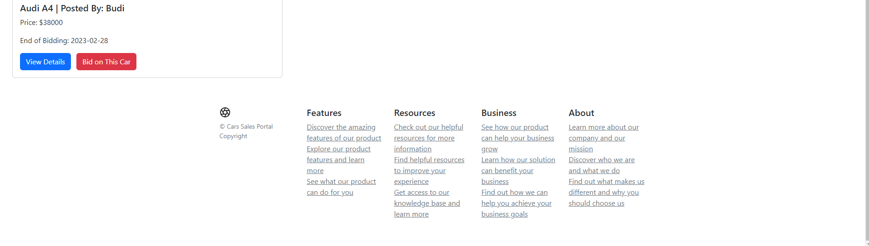

Car Detail

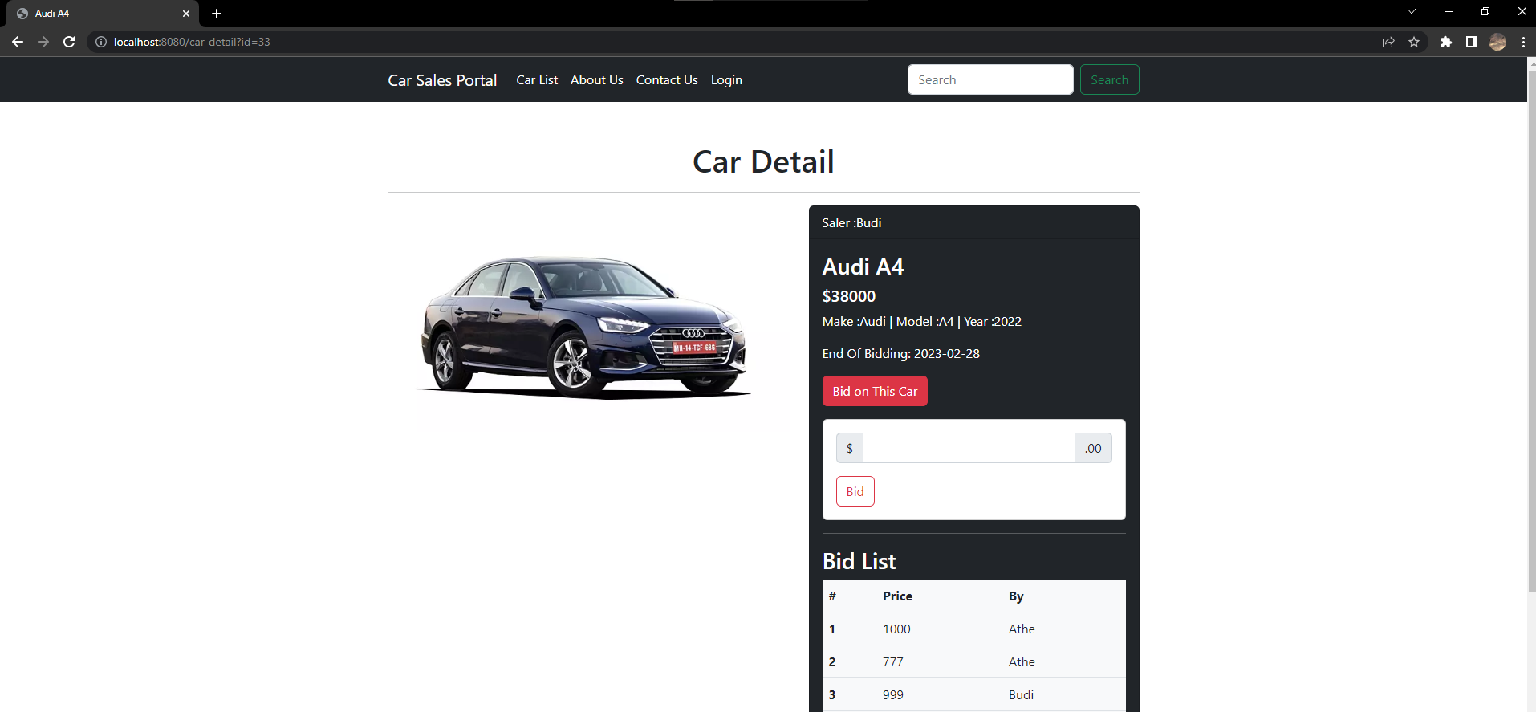

My Store

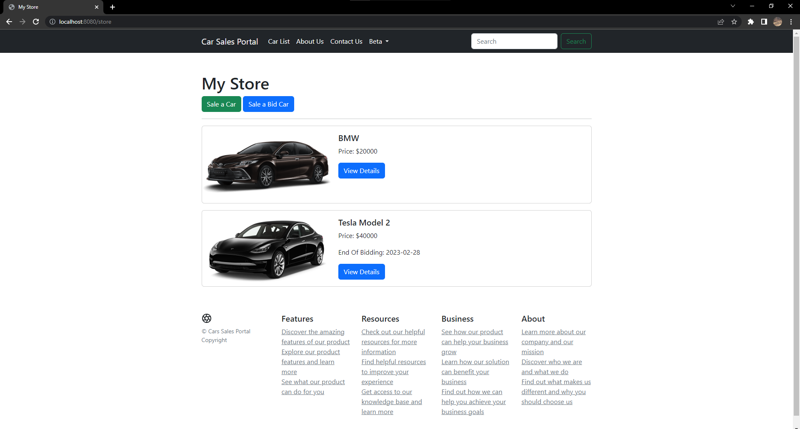

Add Car Page

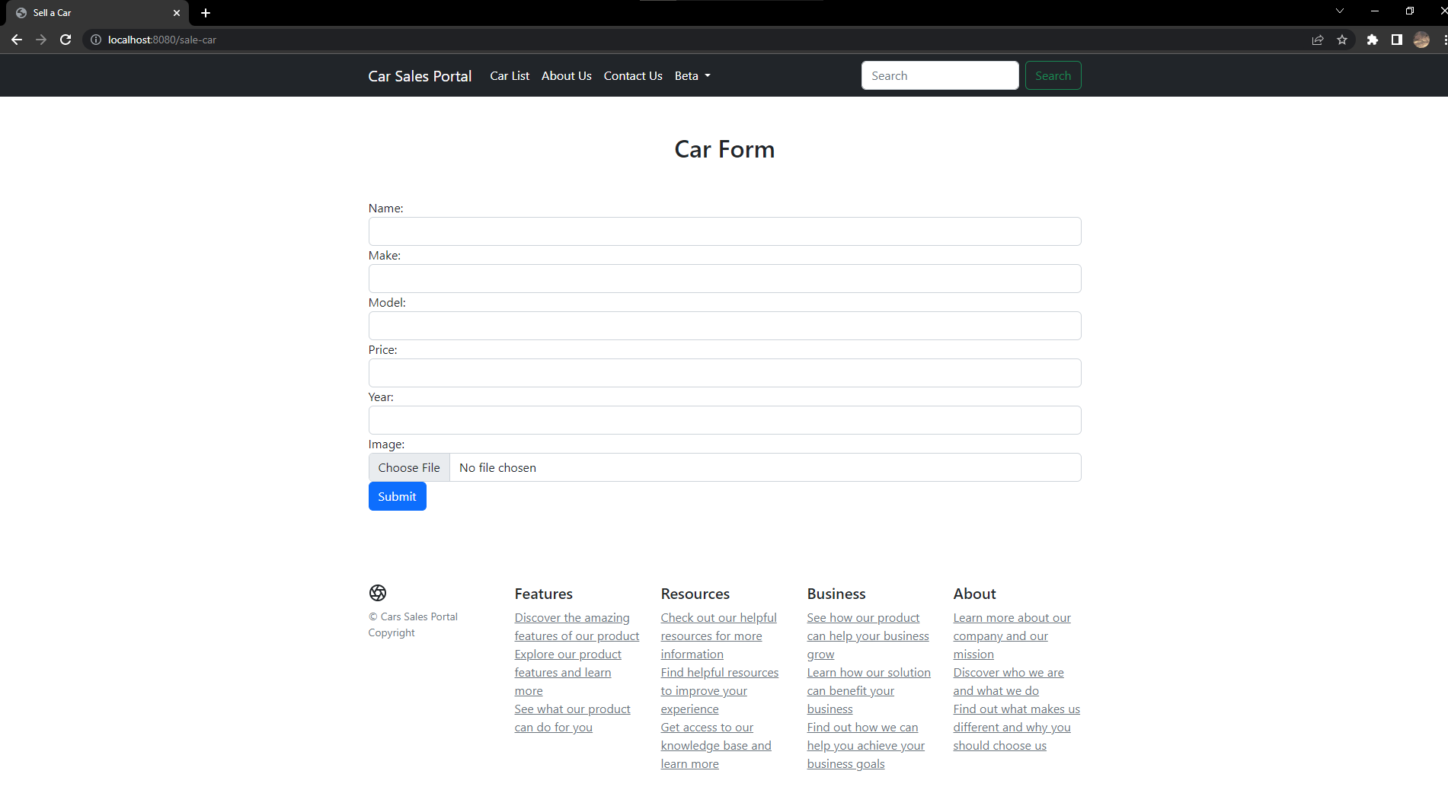

Add Bid Car Page

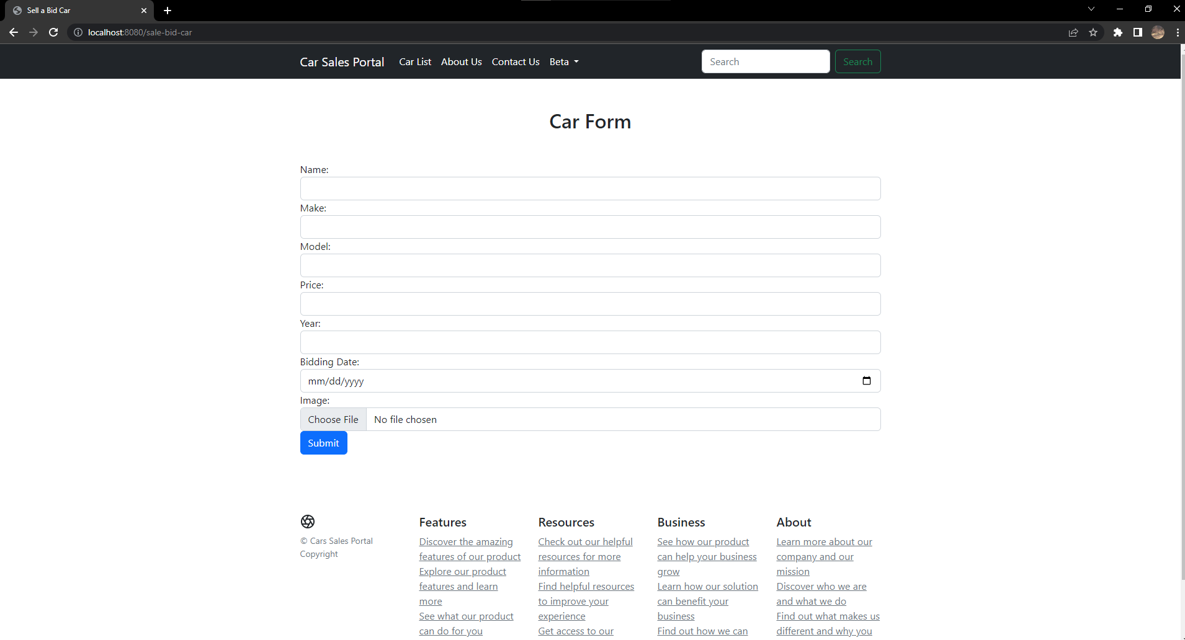

Edit Car Page

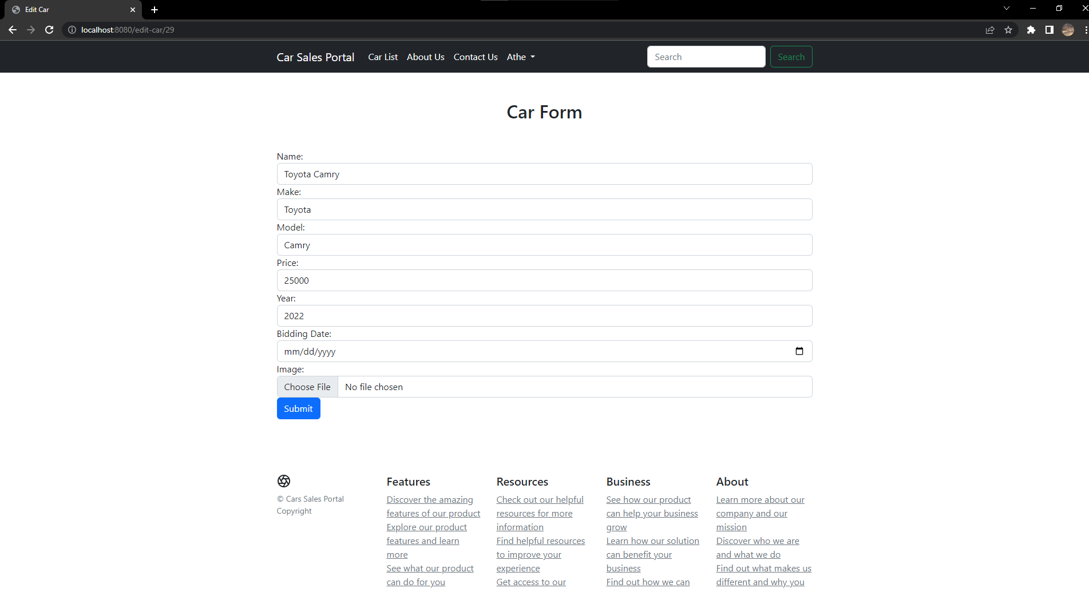

Profile

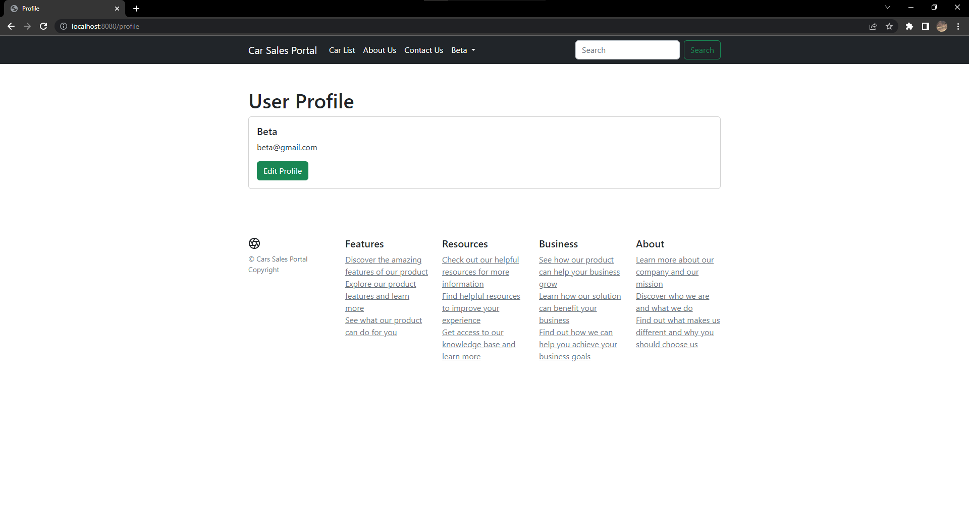

Edit Profile

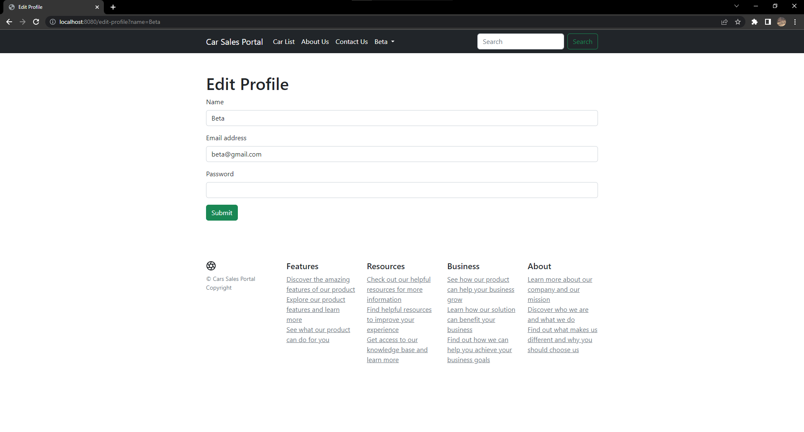

Administration Panel

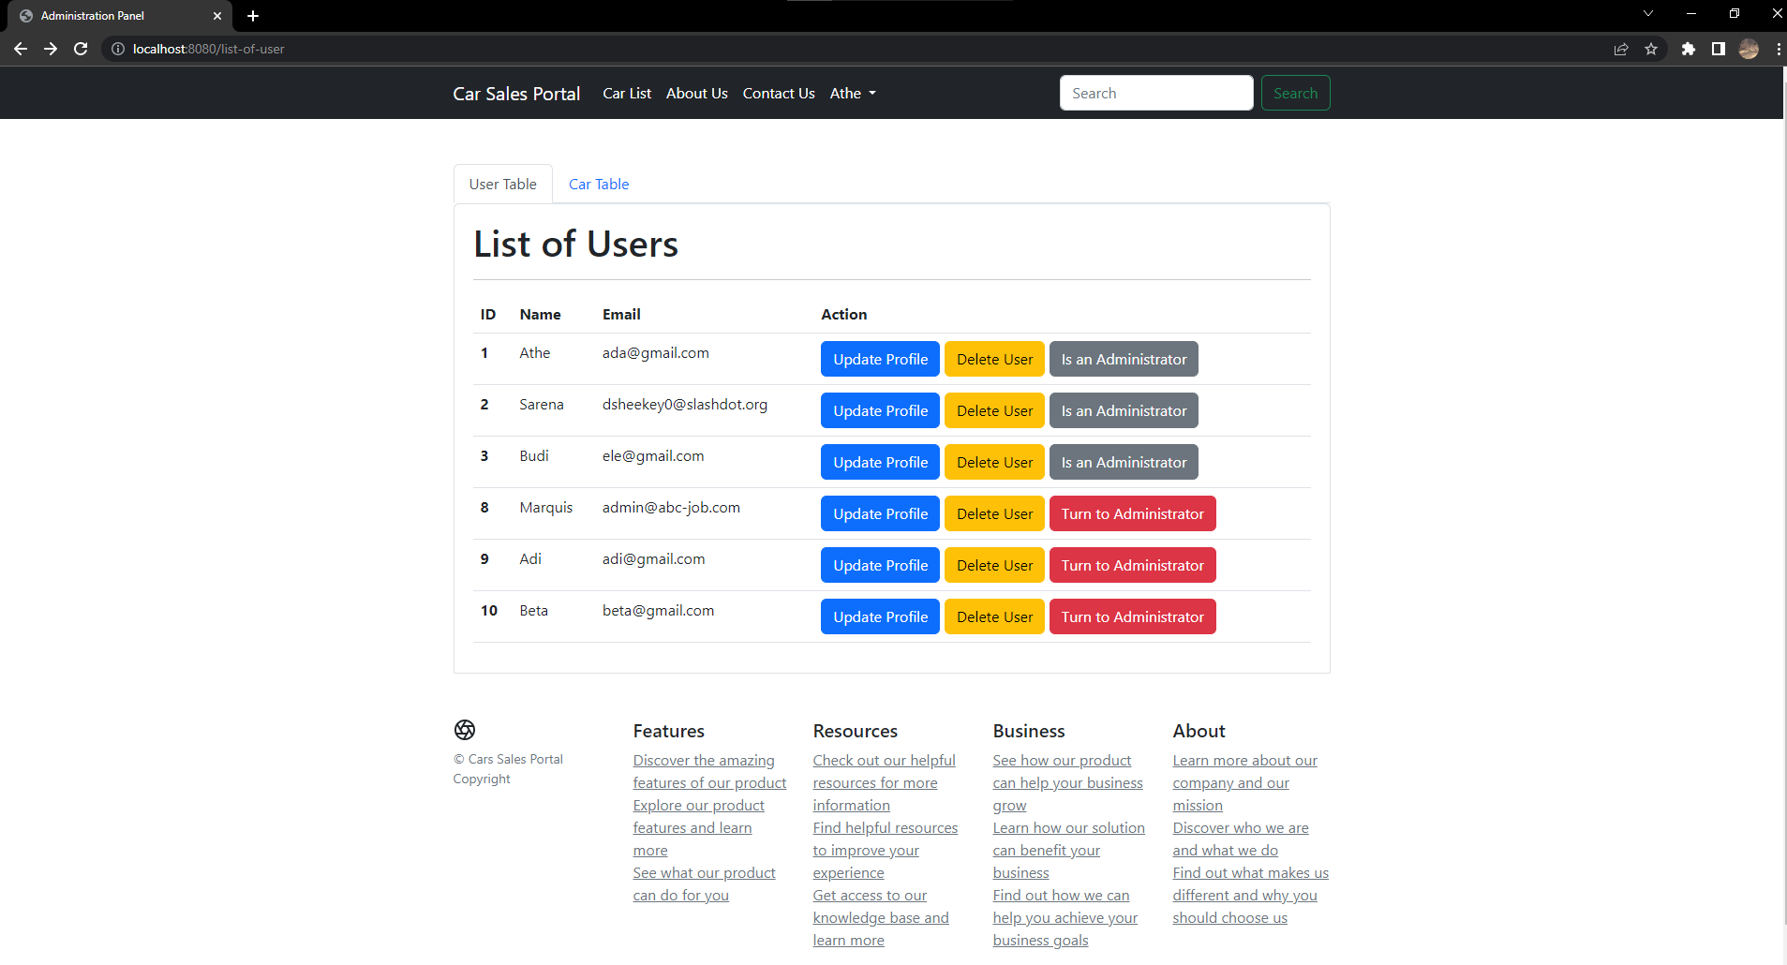

Error Page

